**CHAPTER I**

**Introduction**

This chapter includes the background of the Study that will explain how the system will work and the background for the business. The conceptual framework explains the input, process and output of the system. The chapter also discusses the objectives of this project which are focused on what and how the system will benefit its users and the business. This chapter also includes the general scope of the project, limitations and delimitations. The significance of this study explains the benefits of the system. And to understand all the technical words and used in this documentation, the definition of terms is also included.

**Background of the Study**

In today’s information technology, users need easier and faster system. Time is the highest priority in their life.

The Cuckoo Chef Restaurant is a restaurant that will serve variety of foods that are commonly sold these days like burgers, tacos, wings, pizza, burger, salads, pasta and beverages like beer, alcohol and etc., owned and managed by Mr. Louie- Phillip Miguel M. Flores. He also wants to include activities for his restaurant such as beer pong, burger challenge, spicy chicken wing challenge, Live band, movie night, pay per view for his future customer’s satisfaction because he wants to feel like the restaurant is home for them. His restaurant is located at 116-A.M., Almeda St. in the town of Pateros. He started constructing the restaurant last year, November 2016 and stopped for 3 months due to his parent’s decision and continued constructing in March 2016 and will be expecting to open the business this coming September 2017 with an operating hours of 11 am up to 12 midnight. As Mr. Flores was interviewed and after all the information was gathered, the system analyst come up with the idea of offering ordering and inventory system.

The inventory system will help the owner to monitor the stocks of food, to avoid employee theft and to help his employees to made their work easier because it will allow the user to view the food inventory and to maintain an organized and secured order records. He will also need Ordering System to allow the restaurant to manage what can be ordered by the customer, place order and supply necessary details and provide functionality for the power user administrator.

Web-based Ordering and Inventory System for The Cuckoo Chef simplifies multiple tasks that will reduce stock waste and facilitate a smooth day-to-day operation. The system that will be created will help the restaurant to have an excellent customer service, consistency of ordering, and monitor food availability for his menu. The system also enables the customer to place their orders online but only within Pateros. If those customers from other areas, they can only view what’s the menu then go dine in the restaurant. The system will also provide a user-friendly web pages. Therefore, our system will enhance the speed and standardization of taking the order from the customer and displays it to the staff in the kitchen accordingly. The system can also help the owner to monitor the inventory like the availability of foods and the stocks to avoid food shortage and for the issues like employee theft.

**CONCEPTUAL FRAMEWORK**

The figure below shows the conceptual framework of the Web- based Ordering and Inventory System for The Cuckoo Chef. It shows the input, process, and output of the proposed system.

|  |  |  |  |  |
| --- | --- | --- | --- | --- |
| INPUT   * User account * Order details * Restaurants Menu * Document: * order details * inventory details * Delivery Details (within Pateros only) |  | PROCESS   * Generate Order Reports * Check availability of the products * Retrieve new orders from the database * Process Order Transactions from the Customer * Provide payment details * Select and item from the menu * Review Current Order * Provide Payment Details * Remove an Item * Update food item and price * Determine if the asset is already in surplus , or is it should be purchased |  | OUTPUT   * Menu Management System Module * Web Ordering System Module * Order Retrieval System Module * Inventory Management * Updated food item and price details * Account Creation * Reports:   -order  -inventory |

Feedback

Figure 1.1

Conceptual Framework of Web-based Ordering and Inventory System for the Cuckoo Chef

**OBJECTIVES OF THE PROJECT**

The main objective of the project is to design and create a prototype of a Web-based Ordering and Inventory System for the Cuckoo Chef.

Specifically, the prototype will:

1. **Maintain, organized and secure the restaurant’s order records.** The restaurant might possible experience unorganized records that may cause an anomalies. The business must have a back-up record and keep the restaurant’s order records secured because it can use as a proof if the business encounters a problem with their customer.
2. **Allow users to browse through menu categories.** This is achieved through an easy to use graphical interface menu options.
3. **Allow users update order details.** The users can add any number of items to the cart from any of the available food categories bysimply clicking the Add to Cart button for each item. Once item is added to the cart, user is presented with detailed order to review or continue shopping.
4. **Allow the user to Order the item(s).**This is achieved using the “Proceed to order button” in the cart initially and then “Order” button at last step.Button is disabled when there are no items in the cart.
5. **Allow the user to process the order .** This is achieved when user selects “Check-out Orders” button and view the Order information details.
6. **Allow the user to see success message after placing an order.** This is achieved whenuser successfully places an order. The user is given the order conformation number along withsuccess message.
7. **Allow the user to view the food inventory.** This is achieved when the user can easily monitor the remaining stocks to avoid food surplus or shortage.
8. **Improve the communication between the client and the server and minimize the time of ordering.** One of the main objectives of a restaurant to ensure customer satisfaction. Manual listing of orders by the waiters/waitresses may result to slow response in customer service. Hence, if the restaurant uses the proposed system, manipulation of orders to the customers can be easy and quick.

**SCOPE, LIMIT AND DELIMITATIONS**

The scope of the Cuckoo Chef Ordering and Inventory System is to design a software solution which can help the business in performing their day-to-day operations, improving efficiency, and helping them to be more productive. The system is created to help the owner to easily monitor his inventory. This project will provide a solution through which the company can easily manage, handle and generate all required information in their respective format when needed. The system can be accessed by the owner, customer, and inventory staff. The system can be updated so the user can change what food is available for the customer to know. The system can provide a copy of order. The system stores all the transaction details for the owner & staff to view, manage and monitor it. The system only focuses on the order and customer’s information, availability of the food in the inventory and to maintain and organized all the transaction that has been made.

The proposed system has limited functions only because the goal of study is to meet the needs of business. The system allows customers to order products or services via website. Account Creation and Management only will be used every time a customer places an order. This will allow simplifying the overall user experience. Menu Management System Module provides functionality for the power user-Administrator only. It will not be available to any other users of the system like Restaurant Employees or Customers. For deliveries, the system is limited for customers within Pateros only. The inventory is managed by a staff or the owner himself by listing all the information which can be accessed with a required password.

The business required the system analysts to create a secured and user- friendly online ordering and inventory system. The system will provide a security module which will have three level of access such as Administrators, Members and Guests. Administrator is fully responsible for monitoring and maintaining the website since they have access on some modules which are hidden on guests and even members such as inventory management. The administrator or the owner can deactivate the staffs for inventory management in case of suspicious acts. As for the customers or the guests, they can only browse the website for their input their order details and information needed. The system shall be able to accommodate the present and also the future customers of the business for it should require online request that the customers or guests will take.

**Significance of the Study**

This study will contribute to the improvement of the business Cuckoo Chef Restaurant not only to the staff or the owner of the business but also in the customer. We will ensure this system will encourage the customers and help the owner to grow the business. This Web-Based System will also help the business to grow faster and more recognizable. The outcomes to be considered consist of the following:

**Owner**. The owner will improve the business to get easier work by the help of the ordering and inventory system, it will increase the business’ customers and the business will be more recognizable with its improved technology, and the owner will improve the ordering and inventory controls.

**Customer**. With the use of high technology in Ordering system, the customers will get the satisfaction and their loyalty to the business and the customers will also reduce their food placement time. Customers will also have faster access and services to the Cuckoo Chef Restaurant.

**Staff**. Staffs will have faster access with the customer and order information. Handling orders and confirming orders from customers will be easier. The communication between the staff and customer will be more clearly because the customer will be able to list what they desire and want without unclear conversation, interruption or repetition of orders.

**Definition of terms**

The following words have been selected and interpreted to further understand the research, the following words are defined:

**System Administrator** – The System Administrator is the one who is responsible for the system, ensuring that the administrative activities within the business run efficiently. The

System administrator is the one who facilitate the whole system.

**Online Ordering** – This system is where the customer or the buyer can order what product they want by online

**Online Inventory** – This system is where you can see the product and the background of the business. The term can refer to ads or other traditional media but is increasingly used to refer to online or mobile ads

**Menu Management System Module** - provides functionality for the power user-Administrator only where the administrator has only the right and freedom to control. By the use of graphical interface, it allows the Admin to manage the menu that is displayed to users of the web ordering system such as Add/update/delete food category from the menu, update price for a given food item and additional information (description and photo) for a given food item.

**Web Ordering System Module-** provides the functionality for customers to place their order and supply necessary details. The Cuckoo Chef restaurant’s customers provides the following functionality such create and manage their account, navigate the Cuckoo Chef Restaurant’s menu, select and add product from the menu, review their current order, remove product, provide payment details, receive confirmation and view order placed.

**Order Retrieval System Module-** is designed to be used only by restaurant employees, and provides the following functions such as retrieve new orders from the database and displays the orders in a readable way.

**CHAPTER 2**

**Review of Related Literature and Studies**

This chapter presents a brief discussion of the literature reviewed by the researchers which further enriched the conceptualization of the study and helped in describing the cognitive design that guided the conduct of the researcher. It deals with theoretical concepts and fundamentals that support this project. This chapter includes the related studies, system and technologies to our proposed system that will help us to for the making of Inventory and ordering system.

**RELATED STUDIES**

**System Components for Online Ordering System**

Online [Ordering System](http://www.nibblematrix.com/complete-online-food-ordering-system/) is a website or mobile application through which users can order food online from a food cooperative or even a native restaurant. Ordering food online is similar to online shopping – buying goods online. Once user places an online order, restaurant receives the order, starts processing it and delivers food to the user.

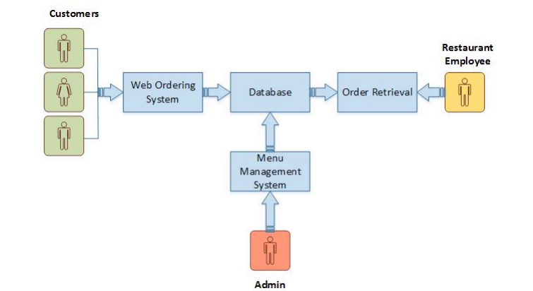

System Components for Online Ordering System

Figure 2.1

The structure of the system can be divided into three main logical components. Web Ordering System provides the functionality for customers to place their order and supply necessary details. Menu Management allows the restaurant to control what can be ordered by the customers. Order Retrieval System is a final logical component because it allows restaurant to keep track of all orders placed. This component takes care of order retrieving and displaying order information.

Web Ordering System Module provides the functionality for customers to place their order and supply necessary details. Users of the system, namely restaurant customers, must be provided the following functionality such create and manage their account, navigate the restaurant’s menu, select and add an item from the menu, review their current order, remove an item, provide payment details, receive confirmation and view order placed.

Menu Management System Module provides functionality for the power user-Administrator only. It will not be available to any other users of the system like Restaurant Employees or Customers. Using a graphical interface, it will allow an Admin to manage the menu that is displayed to users of the web ordering system such as Add/update/delete food category from the menu, update price for a given food item and additional information (description and photo) for a given food item.

Order Retrieval System Module is the simplest module out of all three modules. It is designed to be used only by restaurant employees, and provides the following functions such as retrieve new orders from the database and displays the orders in a readable way.

**System Components for Inventory System**

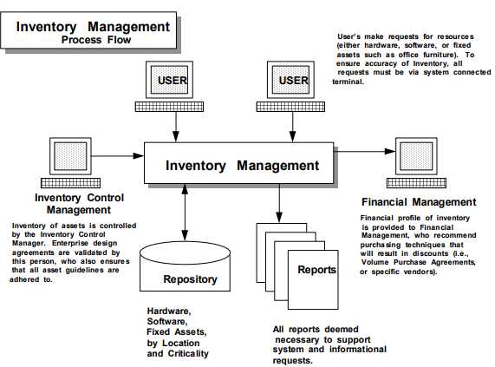

Figure 2.2

Inventory Management System

This figure 2.2 shows the components of an inventory management system. The utilization of Inventory Management Systems to control the purchase and installation of assets can aid in the control of the business environment, while assisting in the assignment of personnel to perform asset related work functions.

To successfully implement an Inventory Management System, it is necessary to integrate it within the everyday functions performed by company personnel. That is, when a user wants to order equipment or software, they would call up the Inventory Management System screen associated with Acquisition. Should a user request the acquisition of a specific type of asset then it would be possible for the inventory system to determine if the asset is already in surplus, or if it should be purchased under an existing Volume Purchase Agreement with a vendor.

**Prototyping**

Prototyping is the process of building a model of a system. In terms of an information system, prototypes are employed to help system designers build an information system that intuitive and easy to manipulate for end users. Prototyping is an iterative process that is part of the [analysis phase](http://www.colorado.edu/infs/jcb/class/analysis.html)of the [systems development life cycle](http://www.colorado.edu/infs/jcb/class/sysdevel.html). (Sauter, 2012).

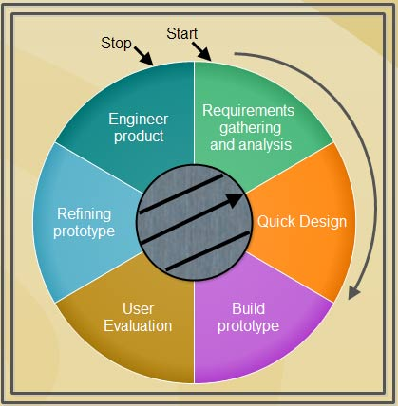

Prototyping Model

Figure 2.3

The prototyping illustrated in Figure 2.3 will be used by the system analyst. A prototyping model begins with requirements analysis and the requirements of the system are defined in detail.

The user is interviewed in order to know the requirements of the system. When requirements are known, a preliminary design or quick design for the system is created. It is not a detailed design and includes only the important aspects of the system, which gives an idea of the system to the user. A quick design helps in developing the prototype.

Information gathered from quick design is modified to form the first prototype, which represents the working model of the required system. Next, the proposed system is presented to the user for thorough evaluation of the prototype to recognize its strengths and weaknesses such as what is to be added or removed. Comments and suggestions are collected from the users and provided to the developer.

Once the user evaluates the prototype and if he is not satisfied, the current prototype is refined according to the requirements. That is, a new prototype is developed with the additional information provided by the user. The new prototype is evaluated just like the previous prototype. This process continues until all the requirements specified by the user are met. Once the user is satisfied with the developed prototype, a final system is developed on the basis of the final prototype.

**Web Application**

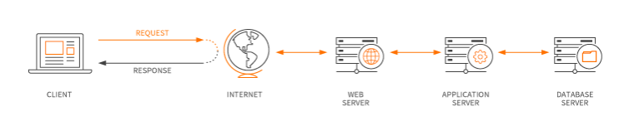

Web Application

Figure 2.4

Figure 2.4 illustrates how the web application utilizes web browsers and web technology to perform tasks over the internet. Web applications are usually coded in browser- supported language such as JavaScript and HTML as these languages rely on the browser to render the program executable. Some of the applications are dynamic, requiring server- side processing. Others are completely static with no processing required at the server.

The web application requires a web server to manage request from the client and then forwards this request to the web application server. Application Server performs the requested task- such as querying the database or processing the data – then generates the results of the requested data that will be sent to the web server. The web server responds back to the client with the requested information that then appears on the user’s display.

**System Testing**

System testing is the type of testing to check the behavior of a complete and fully integrated software product based on the software requirements specification (SRS) document. The system testing will be conducted by the system analyst to evaluate business and end-user requirements. This is black box type of testing where external working of the software is evaluated with the help of requirement documents & it is totally based on Users point of view. For this type of testing do not required knowledge of internal design or structure or code.

 In Software Development Life Cycle the System, testing is perform as the first level of testing where the system is tested as a whole to check if system meets functional requirement or not. System Testing enables you to test, validate and verify both the Application Architecture and Business requirements. The System is tested in an environment that particularly resembles the effective production environment where the application will be lastly deployed.

**­Related System­­­­**

The systems that will be shown in Related System are the Ordering and Inventory systems that are related to the project. The following related system will benefit and help the analysts develop the system prototype.

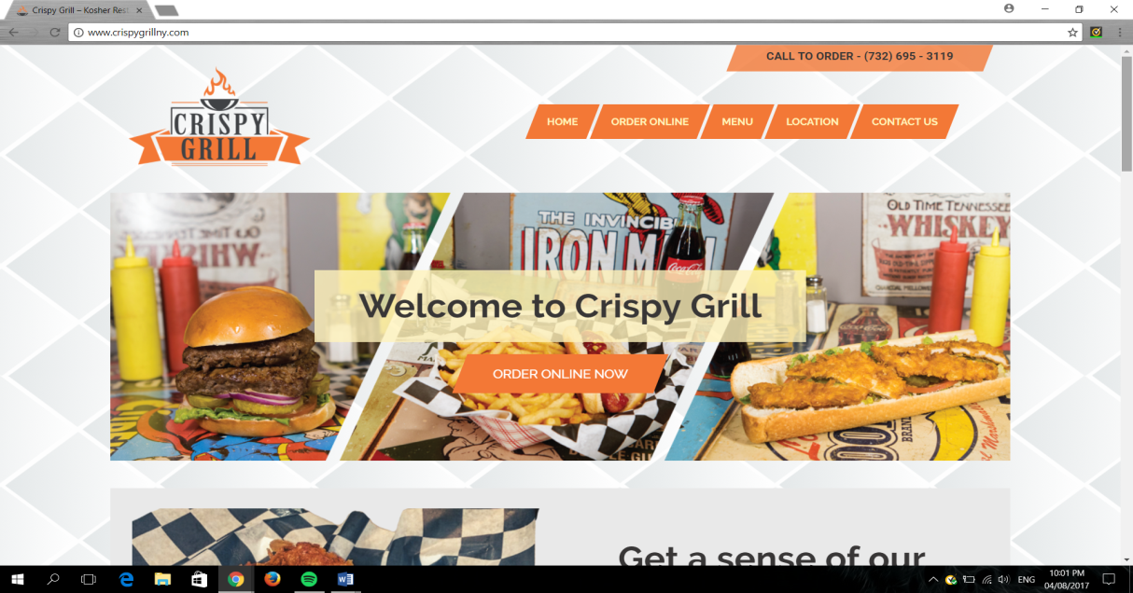

Figure 2.5

Homepage of Crispy Grill

Figure 2.5 is the screenshot of Crispy Grill’s Online Ordering System for their customers. The homepage is the most important part of the website and it serves as table of contents to the customer.

The first thing that the customers will see is the greeting of Crispy Grill to them. This content will show the customers the important details of their restaurant like Order Online, Menu, Location and Contact Us and the automatic display of their telephone number that will guide and help them in ordering online.

In contrast between Crispy Grill and The Cuckoo Chef Restaurants, they both have the same functionalities. In comparison, the design and appearance of Crispy Grill will be different with the Cuckoo Chef Restaurant.

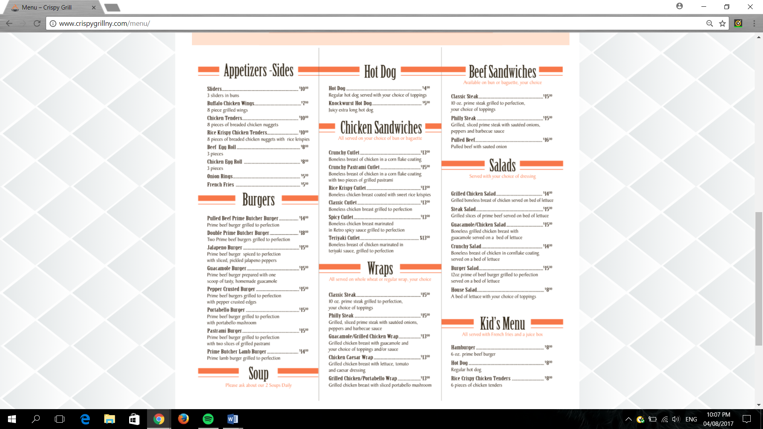

Figure 2.6

Crispy Grill’s Menu

Figure 2.6 are the screenshot of main menu and promotion of Crispy Grill. This interface shows all the food that Crispy Grill offers. American-inspired foods is the style of foods that they offer.

The difference of Crispy Grill’s menu with the menu of The Cuckoo Chef Restaurant are the listing of foods and the costings. The Cuckoo Chef Restaurant will have burgers, tacos, wings ,pizza, burger, salads, pasta, beverage like beer, alcohol, shakes and so on on the list of the menu, since the Crispy Grill is more on American-styled food, the Cuckoo Chef Restaurant is *tex-mex* (texan-mexican) style. The design and theme of Crispy Grill will also be different with The Cuckoo Chef Restaurant to make the appearance better for the customers.

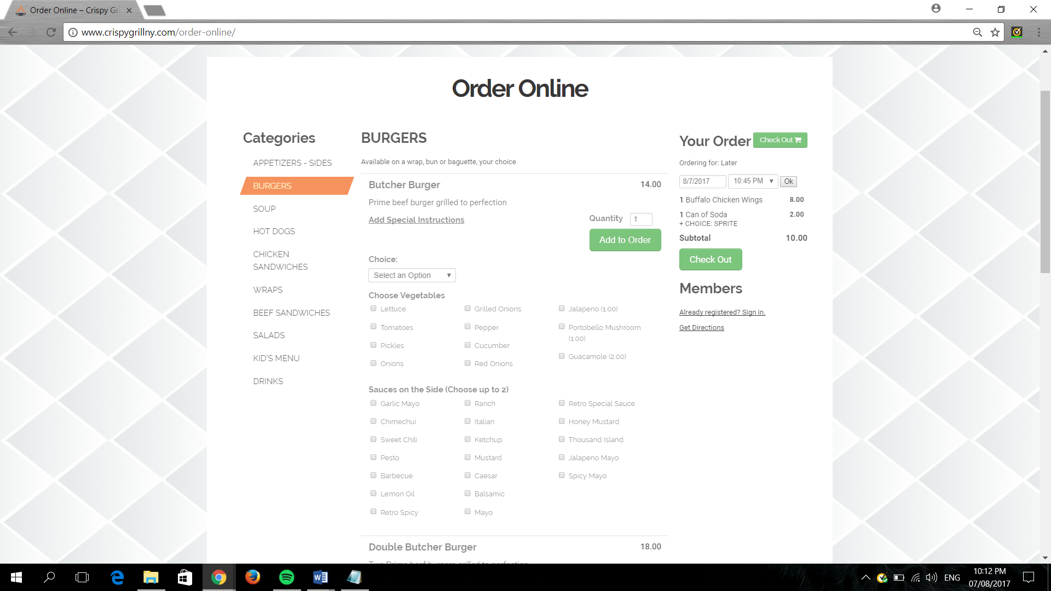

Figure 2.7

Order Online Interface

This screenshot interface shown in Figure 2.7 is the online ordering part of Crispy Grill. This interface shows the ingredients that will be added on the order of the customer.

Other options is also applied on other foods like flavors, sauces and so on. The customer has the freedom to add what they desire to achieve their satisfaction.

Having options of ingredients, flavors, sauces and so on to choose in the Crispy Grill restaurant will also be the same with the Cuckoo Chef Restaurant’s online ordering. The similairty of proposed system to Crispy Grill, The Cuckoo Chef Restaurant will also have the options for customizations of customer’s order online.

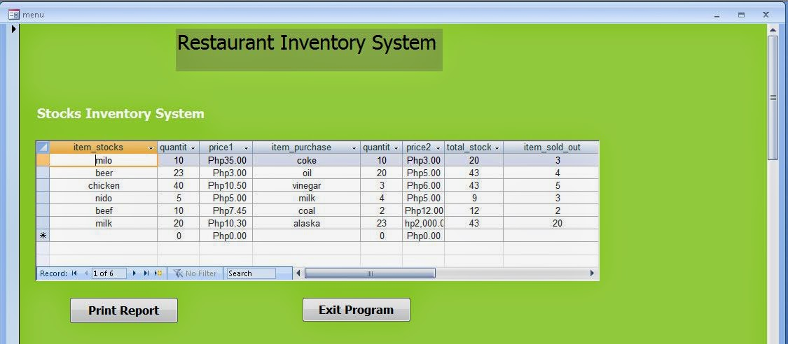

Figure 2.8

Inventory System Interface of Restaurant Inventory System

The inventory system shown in figure 2.8 displays the stock items, stock quantity, stock units, items sold out which displays what has the highest demand product and etc of the inventory system. it is designed for admin to keep updated and keep in track the stocks on hand of the restaurant.

This interface is only accessible by the administrator/s to see the contents of the inventory. Administrator/s can input, edit, delete and update the information of the stocks. With the use of the Restaurant Bistro’s inventory system, the administrator/s can view the stocks easily by sorting in alphabetical or by location and choosing other categories depending on which type of food the admin wants to access or view and the administrator/s can also see the best-selling product by viewing the items sold out.

Some of the feature of the Restaurant invetory system will be used in The Cuckoo Chef Restaurant like the quantity and unit of the stocks and items sold out except for the unit price and the value.

Features like items sold out, stock, and quantity are the prior needs of The Cuckoo Chef Restaurant to keep in track in the inventory system to supply the orders of the customers that is why the Restaurant Inventory System’s feature is important to help the Cuckoo Chef Restaurant inventory system track and be updated with the supplies.

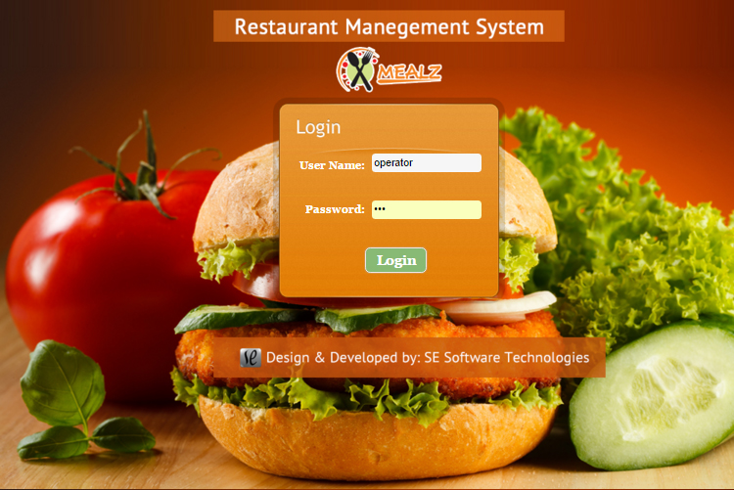

Figure 2.9

Admin Log in Page Interface

The log in page interface shown in figure 2.9 shows the username and password of the admin and other people who has authorization to access the inventory. Log in page is one of the important content of accessing inventory system, it provides strong security to avoid hackers by hacking the system and avoids the employee to access the inventory.

This interface can access the inventory system with the use of administrator/s username and password. It is designated to protect the important details of the inventory that is only meant for the administrator/s.

The Cuckoo Chef Restaurant is important to have log in page in the inventory system to protect the stocks from employee theft and other system security problems. Log in Page will help the admin to have the privacy in accessing the inventory.

**RELATED TECHNOLOGY**

**Data Manipulation/Data Query Language: My SQL**

**My SQL**

MySQL is an open source relational database management system based on Structured Query Language . MySQL runs on virtually all platforms, includingLinux, UNIX, and Windows. Although it can be used in a wide range of applications, MySQL is most often associated with web-based applications and online publishing and is an important component of an open source enterprise stack called LAMP. LAMP is a Web development platform that uses Linux as the operating system, Apache as the Web server, MySQL as the relational database management system and PHP as the object-oriented scripting language. We are comfortable to use this kind of programming languange because we used a lot this one in are major subject.

**Web design / Web Authority**

**Adobe Dreamweaver cs5**

Dreamweaver remains one of the most popular professional web design programs available. It offers a lot of power and flexibility for both designers and developers. There are a lot of features, which can make it intimidating, but in general, it is easy to pick up and start using and the advanced features make it possible to go from beginning web designer to professional in a very short period of time.

Dreamweaver is a WYSIWYG editor and code editor for Windows and Macintosh. Users can use it to write HTML, CSS, JSP, XML, PHP, JavaScript, and more. It can read WordPress, Joomla!, and Drupal templates and it includes [a grid system](https://www.thoughtco.com/use-grid-system-in-graphic-design-1697574) to do grid-based responsive layouts for three different device sizes at once. Plus, Dreamweaver offers a lot of tools for doing mobile web development including creating native apps for iOS and Android devices.

The System analyst use this to design the Web page of the Cuckoo Chef Restaurant, to get more customer with the help of this new technology

**Scripting language**

**PHP**

PHP is a [server-side scripting](https://en.wikipedia.org/wiki/Server-side_scripting" \o "Server-side scripting) language designed primarily for [web development](https://en.wikipedia.org/wiki/Web_development" \o "Web development) but also used as a [general-purpose programming language](https://en.wikipedia.org/wiki/General-purpose_programming_language" \o "General-purpose programming language). Originally created by [Rasmus Lerdorf](https://en.wikipedia.org/wiki/Rasmus_Lerdorf" \o "Rasmus Lerdorf) in 1994, the PHP [reference implementation](https://en.wikipedia.org/wiki/Reference_implementation" \o "Reference implementation)is now produced by The PHP Development Team. PHP originally stood for Personal Home Page, but it now stands for the [recursive acronym](https://en.wikipedia.org/wiki/Recursive_acronym" \o "Recursive acronym) PHP: Hypertext Preprocessor.

PHP code may be embedded into [HTML](https://en.wikipedia.org/wiki/HTML" \o "HTML) or HTML5 [markup](https://en.wikipedia.org/wiki/Markup_language" \o "Markup language), or it can be used in combination with various [web template systems](https://en.wikipedia.org/wiki/Web_template_system), [web content management systems](https://en.wikipedia.org/wiki/Web_content_management_system) and [web frameworks](https://en.wikipedia.org/wiki/Web_framework). PHP code is usually processed by a PHP [interpreter](https://en.wikipedia.org/wiki/Interpreter_(computing)" \o "Interpreter (computing)) implemented as a [module](https://en.wikipedia.org/wiki/Plugin_(computing)" \o "Plugin (computing)) in the web server or as a [Common Gateway Interface](https://en.wikipedia.org/wiki/Common_Gateway_Interface" \o "Common Gateway Interface) (CGI) [executable](https://en.wikipedia.org/wiki/Executable). The [web server](https://en.wikipedia.org/wiki/Web_server" \o "Web server) software combines the results of the interpreted and executed PHP code, which may be any type of data, including images, with the generated [web page](https://en.wikipedia.org/wiki/Web_page" \o "Web page). PHP code may also be executed with a [command-line interface](https://en.wikipedia.org/wiki/Command-line_interface" \o "Command-line interface) (CLI) and can be used to implement [standalone](https://en.wikipedia.org/wiki/Computer_software" \o "Computer software) [graphical applications](https://en.wikipedia.org/wiki/Graphical_user_interface).The standard PHP interpreter, powered by the [Zend Engine](https://en.wikipedia.org/wiki/Zend_Engine" \o "Zend Engine), is [free software](https://en.wikipedia.org/wiki/Free_software" \o "Free software) released under the [PHP License](https://en.wikipedia.org/wiki/PHP_License" \o "PHP License). PHP has been widely ported and can be deployed on most web servers on almost every [operating system](https://en.wikipedia.org/wiki/Operating_system" \o "Operating system) and [platform](https://en.wikipedia.org/wiki/Computing_platform), free of charge.

The System analyst used this programming language for the web development of the Inventory and Ordering System of the Cuckoo Chef Restaurant**.**

**Query language**

**My Sql**

MySQL is an open source relational database management system (RDBMS) based on Structured Query Language (SQL). LAMP is a Web development platform that uses Linux as the operating system, Apache as the Web server, MySQLas the relational database management system and PHP as the object-oriented scripting language.

The System Analyst used this to hold the data from the database system of the Cuckoo Chef Restaurant.

**Web Design**

**Adobe Photoshop**

**Adobe Photoshop** is the predominant photo editing and manipulation software on the market. Its uses range from full featured editing of large batches of photos to creating intricate digital paintings and drawings that mimic those done by hand.

The System Analyst used this to design the web page of the Cuckoo Chef Restaurant page to be more attractive to the customer.

**CHAPTER 3**

**Methods and Procedure**

For this chapter, the methods and procedure taken by the developers are shown. This chapter is important for the developing of the new system because the methods and procedures will serve as developer’s guide in designing and creating the Ordering and Inventory System for the Cuckoo Chef Restaurant. It can also serve as a model for future preferences.

**Setting of the Study**

The setting of the study includes the Data Flow Diagram of the new proposed system. Data Flow Diagram will show the flows of the activity of what the inventory and ordering will do for the Cuckoo Chef Restaurant.

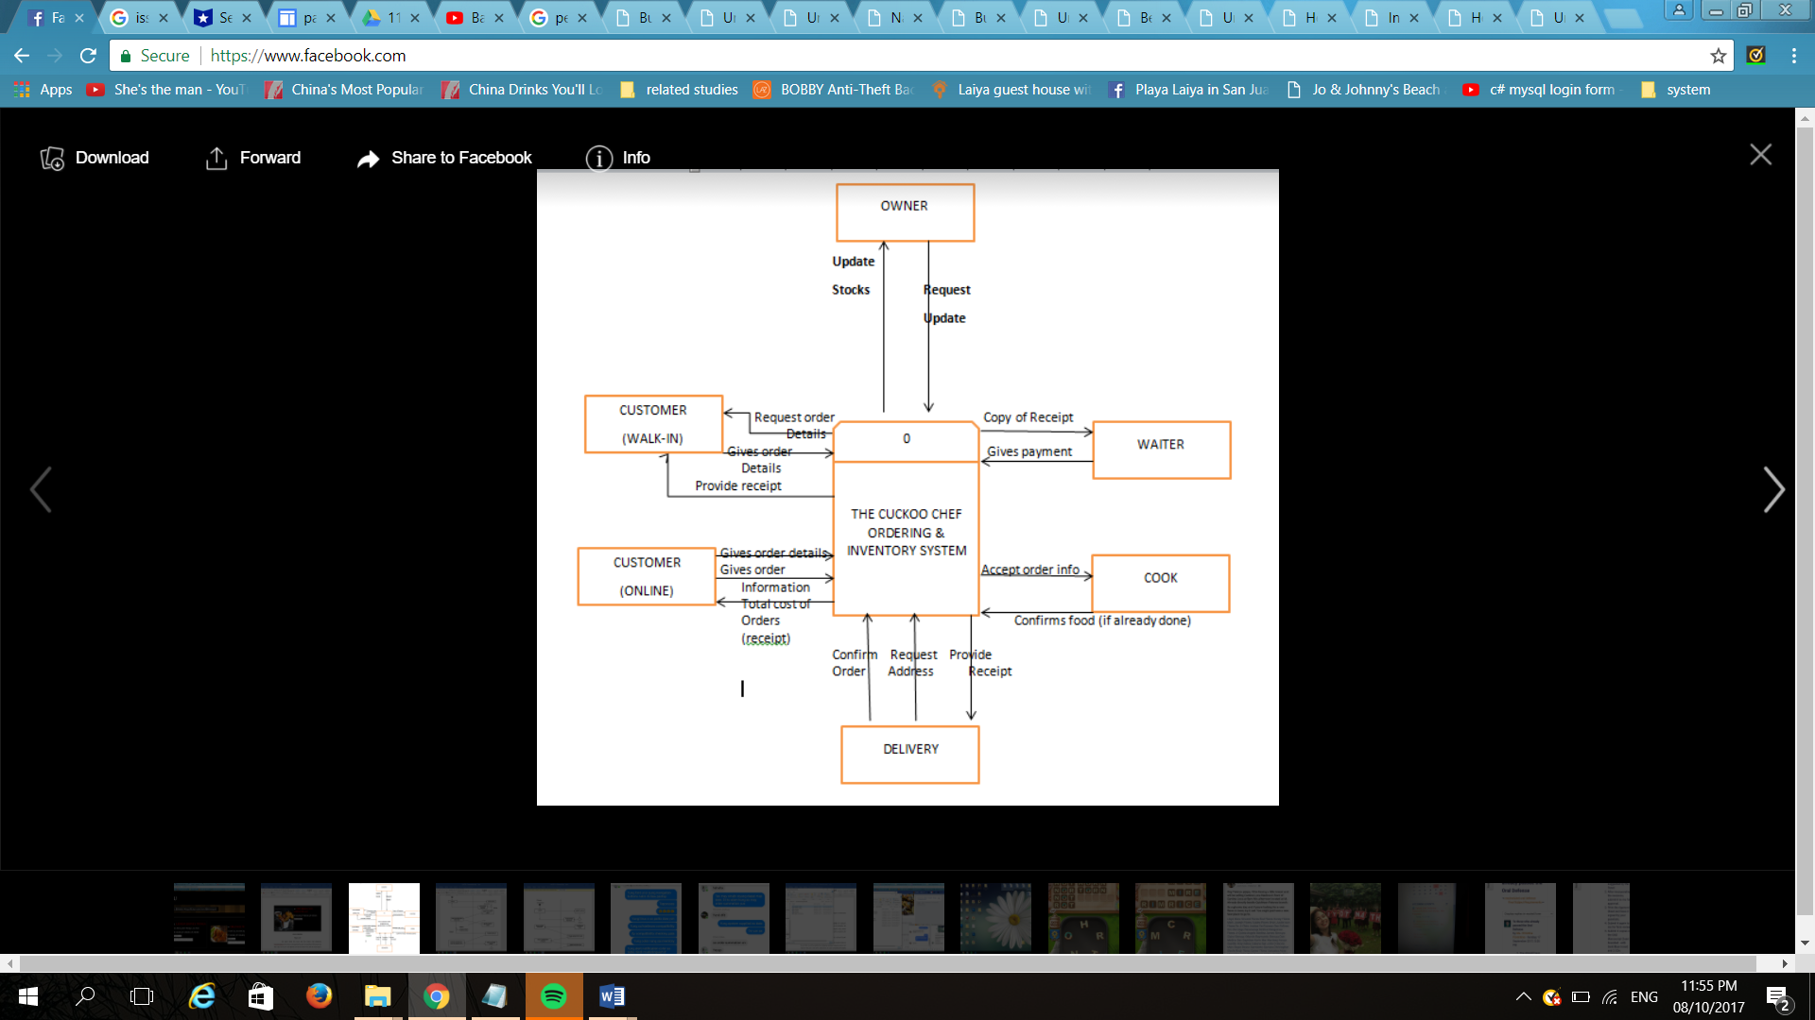

DFD of The Cuckoo Chef Restaurant

Figure 3.1

The figure shown in Figure 3.1is the (DFD) Data Flow Diagram for the Cuckoo Chef, it explains about the overview of the system, this shows what are the information will be input and output from the system, how the data will advance through the system, and where the data will be stored. Every entity of the system explains what are the processes going to happen.

**Project Feasibility**

The Project Feasibility is the initial stage of the project that is used to assess the strength and weaknesses of the proposed system or whether the project will be viable, this stage of project brings together the elements of knowledge that indicate if a project is possible or not.

**Operational Feasibility**

Operational Feasibility determines if a project or end result of a project is feasible and beneficial. This also measure how well the system will solve the problem. Operational feasibility is mainly concerned with issues like whether the proposed system will be used if it is developed and implemented.

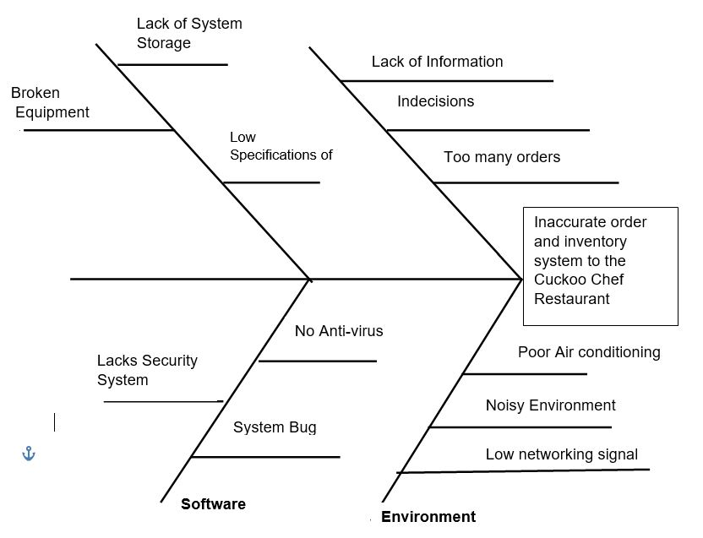

Fish bone Diagram of Inventory and Ordering System for the Cuckoo Chef Restaurant

Figure 3.2

The fishbone diagram shown in figure 3.2 is also called a cause and effect diagram or Ishikawa diagram, a visualization tool for categorizing the potential causes of a problem in order to identify its root causes. The fishbone has an ancillary benefit as well. Because people by nature often like to get right to determining what to do about a problem, this can help bring out a more thorough exploration of the issues behind the problem – which will lead to a more robust solution.

This Figure 3.2 shows the Fishbone Diagram’s problem and root causes of The Cuckoo Chef Restaurant. The System Analysts discuss about the possible problems that will happen in The Cuckoo Chef Restaurant like in the problem that will be encounter with the People, Customer’s lack of information, Indecision and too many orders. The Cuckoo Chef Restaurant will encounter some possible problem in machine like Lack of System Storage, Low Specification of computer and broken Equipment. The possible problem of The Cuckoo Chef Restaurant in Environment is the Poor Air Conditioning, Noisy Environment and Low networking signal. The possible problem in Software is that the system might not have an Anti-Virus, System Bug and Lacks Security System, these are the possible problem that The Cuckoo Chef Restaurant will encounter.

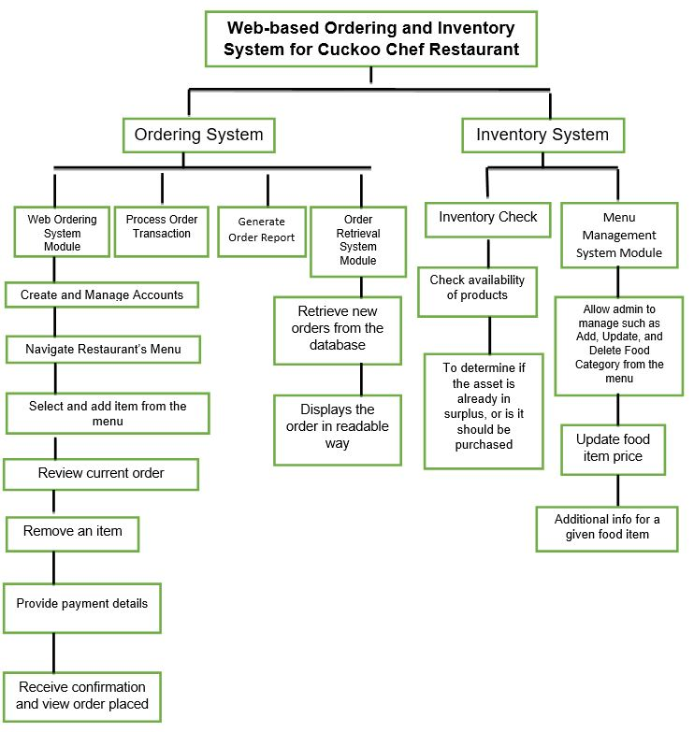

Functional Decomposition Diagram of Inventory and Ordering System for the Cuckoo Chef Restaurant

Figure 3.3

A decomposition diagram shows the high-level function, process, organization, data subject area, or other type of object broken down into lower level, more detailed components. Decomposition diagrams represent organizational structure or functional decomposition into processes. Decomposition diagrams provide a logical hierarchical decomposition of a system.

This Figure 3.3 shows every detail of how the Ordering and Inventory System will work, input, the function, process, and the output. It will discuss the module of the proposed systems followed by the detailed process and the outputs in the end.

**Technical Feasibility**

Under technical feasibility, table 3.1 shows the specifications of hardware resources for development and implementation, network implementation and software resources for development and implementation needed to be able the proposed system prototype functions.

|  |  |
| --- | --- |
| HARDWARE RESOURCES USED FOR DEVELOPMENT | |
| Component/Item | Minimum Requirements |
| RAM | 4GB RAM |
| Processor | Quad Core 2.4 GHZ (i3) |
| CPU | Intel Core i3 G3220 3.0GHZ |
| Monitor | 15.6inch LCD, LED |
| DVD Drive | 24x Sata |
| Mother Board | Z1OPE-D16110G-25 |

|  |  |
| --- | --- |
| HARDWARE RESOURCES USED FOR IMPLEMENTATION | |
| Printer | Ink Jet |
| Component/Item | Minimum Requirements |
| LAPTOP | 15 05-571 G-77 AV |

|  |  |  |
| --- | --- | --- |
| NETWORK RESOURCES USED FOR IMPLEMENTATION | | |
| Component/Item | | Minimum Requirements |
| Internet | | 3 MBPS |
| Web Hosting | * Web Space (5,000 MB) * Operating Systems (Linux/Windows) * Monthly Bandwidth (30,000 MB) | |

|  |  |
| --- | --- |
| SOFTWARE RESOURCES USED FOR DEVELOPMENT | |
| Category | Minimum Requirements |
| Domain Name | Resto.com.ph |
| Web Browser | Google Chrome 62.0 |
| Programming Language | PHP |
| DBMS | MY SQL Version 6.3 |
| Web Authoring Software | Adobe Dreamweaver CS5 Version |

|  |  |
| --- | --- |
| SOFTWARE RESOURCES USED FOR IMPLEMENTATION | |
| Category | Minimum Requirements |
| Domain Maintenance | Resto.com.ph |
| Database Maintenance | My SQL Enterprise Edition Subscription |

Compatibility checking (hardware / software and other technologies) for the Cuckoo Chef Restaurant

Table 3.1

In this figure it shows the products and software and the specification will be used for the development of the proposed system. These serves as guide for the owner to prevent from any hassles and interruptions and loading of the data in the hardware that will use.

**Schedule Feasibility**

Schedule Feasibility is defined as the probability of a project to be completed within its scheduled time limits, by a planned due date. Inventory and ordering system has a high probability to be completed on-time if the schedule feasibility is appraised high. The inventory and ordering system will be unsuccessful if it takes longer than it was estimated: some external environmental conditions may change. Hence a project can lose its benefits, expediency and profitability.

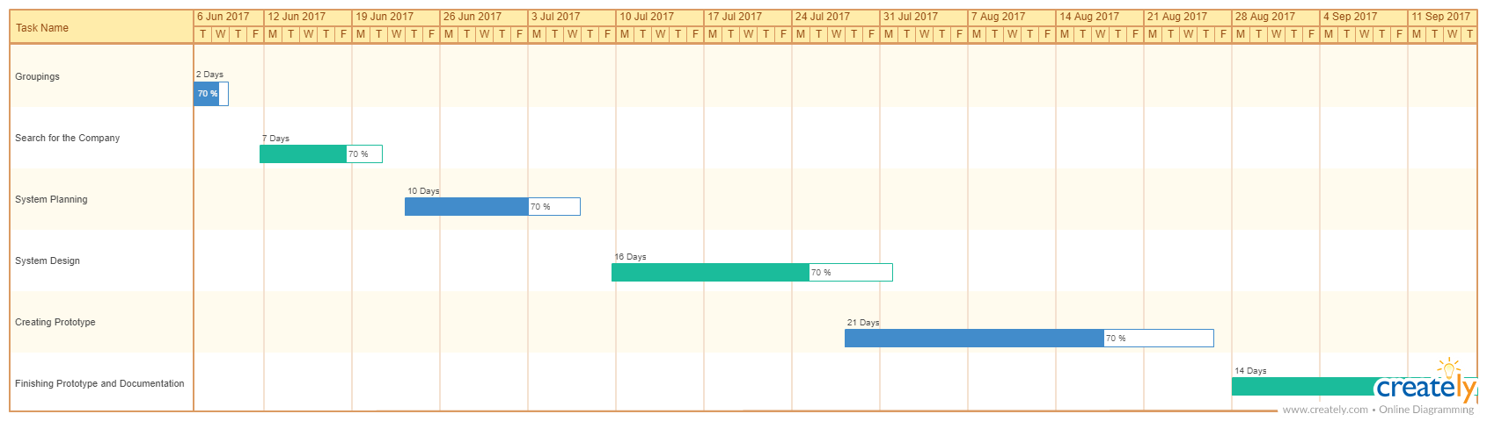

Gantt Chart of Inventory and Ordering System for the Cuckoo Chef Restaurant

Figure 3.4

A Gantt chart is a horizontal bar chart developed as a production control tool in 1917 by Henry L. Gantt, an American engineer and social scientist. Frequently used in project management. A Gantt chart provides a graphical illustration of a schedule that helps to plan, coordinate, and track specific tasks in a project. Gantt charts give a clear illustration of project status, but one problem with them is that they don't indicate task dependencies. This figure will present the graphical illustration of the system analysts schedule in making the proposed system from the beginning. The Gantt chart helps the system analysts to track the works because this shows the amount of work done or production completed.

**Requirements Modelling**

Requirements modelling represent the input, process and output of the system prototype. The interfaces will be included in the requirement modelling the same with the tables and activities of the inventory and ordering system. This will also contain the software, hardware and programs used in developing the inventory and ordering system.

**Input**

Illustrations of use case diagram, interfaces of prototype system, design of forms and data dictionary will be shown under input.

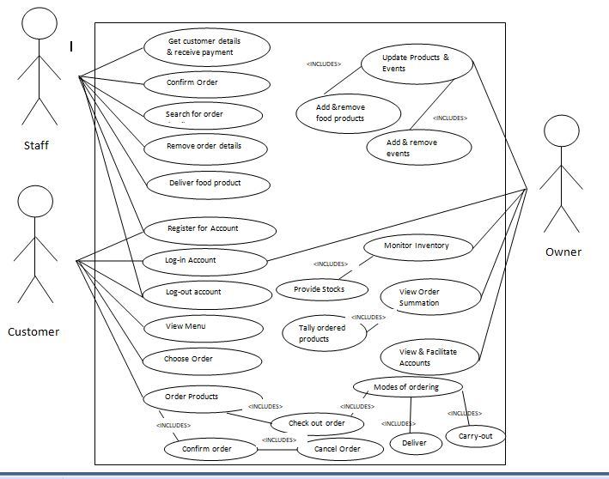

Use Case Diagrams of Inventory and Ordering System for the Cuckoo Chef Restaurant

Figure 3.5

The [use case](http://searchsoftwarequality.techtarget.com/definition/use-case) is a methodology used in system analysis to identify, clarify, and organize system requirements. In this context, the term "system" refers to something being developed or operated, such as a mail-order product sales and service [Web site](http://searchsoa.techtarget.com/definition/Web-site). Use case diagrams are employed in [UML](http://searchsoftwarequality.techtarget.com/definition/Unified-Modeling-Language) (Unified Modelling Language), a standard notation for the modelling of real-world objects and systems.

This Figure shows the Use Case Diagram to know the role of the actors in the Ordering and Inventory System for The Cuckoo Chef Restaurant. The users are the Staff, Customer and Owner. The role of the Staff is to List Food, Provide Food Information, get customer Information and Deliver Food. The role of the Customer is to request information and suggest some recommendation and the role of the owner is to change information, produce product information and to facilitate the tally of the menu given in everyday, to provide stocks, to know the list of stocks needed and to monitor all of the stocks

**Screen Shot of Interfaces of Prototype**

**User Interface: Customer**

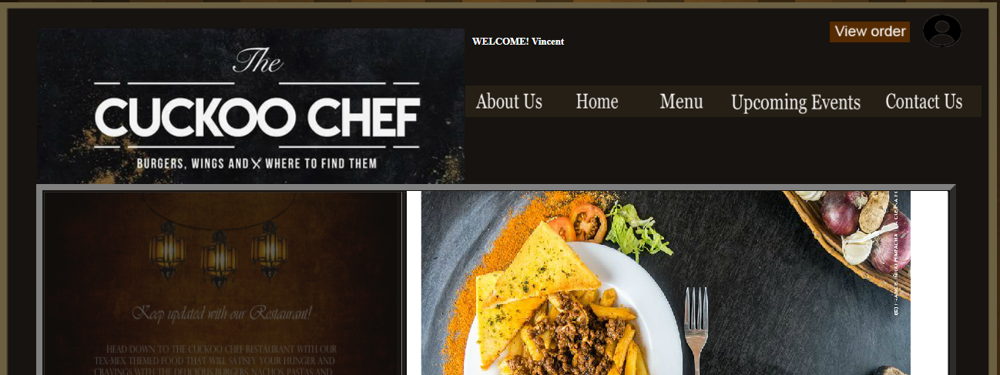

**The Cuckoo Chef Web Page**

**Figure 3.6**

Figure 3.6 shows the web page of the Cuckoo Chef Restaurant where the customer can see the Cuckoo Chef Restaurant through web or online. The left side part of the interface is for the page’s categories. The right side of the interface contains the content of the categories to be selected.

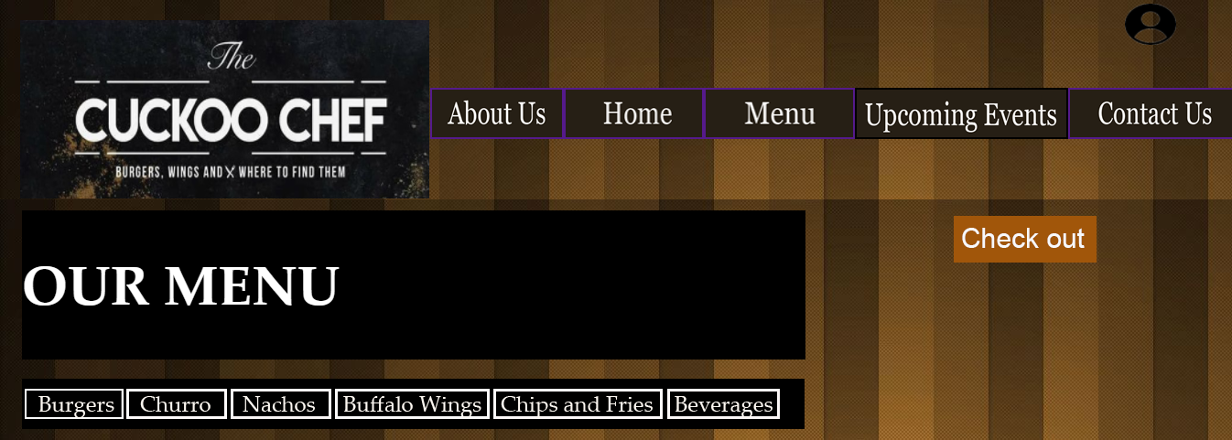

**The Categories for the Cuckoo Chef Web Page**

**Figure 3.7**

The figure 3.7 shows the categories in the left side of the webpage for The Cuckoo Chef Restaurant. The customer can select any categories such as “About us,” “Home”, “Menu”, “Upcoming Events” and “Contact us”. If the “About us” is clicked, the short background for The Cuckoo Chef Restaurant will appear on the right side of the page. If the “Home” is clicked, the “Log-in” will appear where the customer can log-in their accounts. If the “Menu” is clicked, the customer can pick what food category the customers wants. If the “Upcoming Events” is clicked, all the announcements for the restaurant will appear. If the “Contact us” is clicked, the contact information for the restaurant will appear.

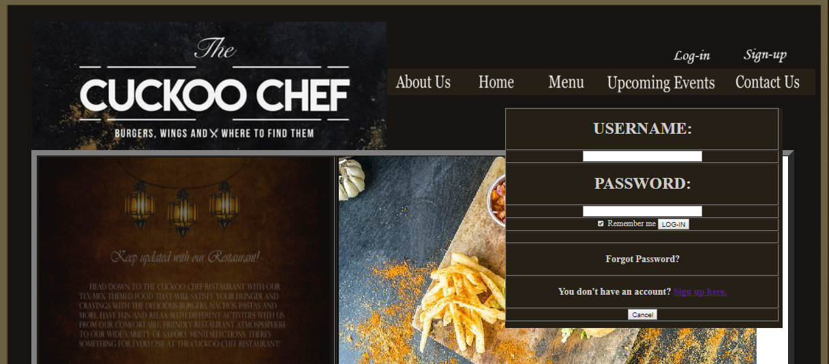

**Log-in**

**Figure 3.8**

The figure shows the Log-in interface that will appear when the “Home” is clicked. It contains the username and password for the customer to input if they created an account in the web page of The Cuckoo Chef Restaurant. If the customer does not have an account, the customer can click the “Sign up here” that is highlighted to redirect to registration for account creation.



**Food Menu Categories**

**Figure 3.9**

The Figure show the menu bar where the customers or users can choose what order they prepare. The business offers some burger, churro, nachos, buffalo wing, chips and fries and beverages, these are the different menus of food of The Cuckoo Chef Restaurant.

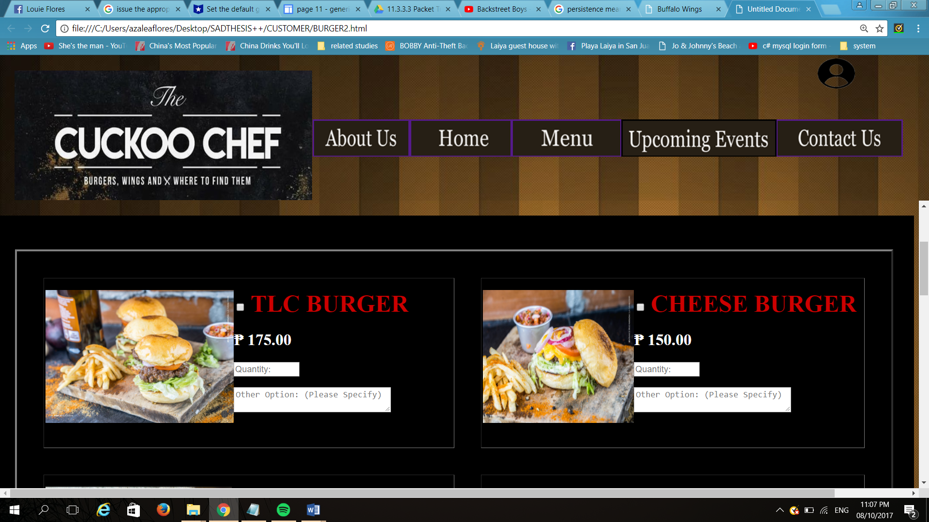

**Burgers Selection**

**Figure 3.10**

The figure shows the different burger type that The Cuckoo Chef Restaurant have, the customer can choose what burgers they want and input or select what quantity the customers prefer. The customer can see their checked order if they click the burgers sign in menu bar.

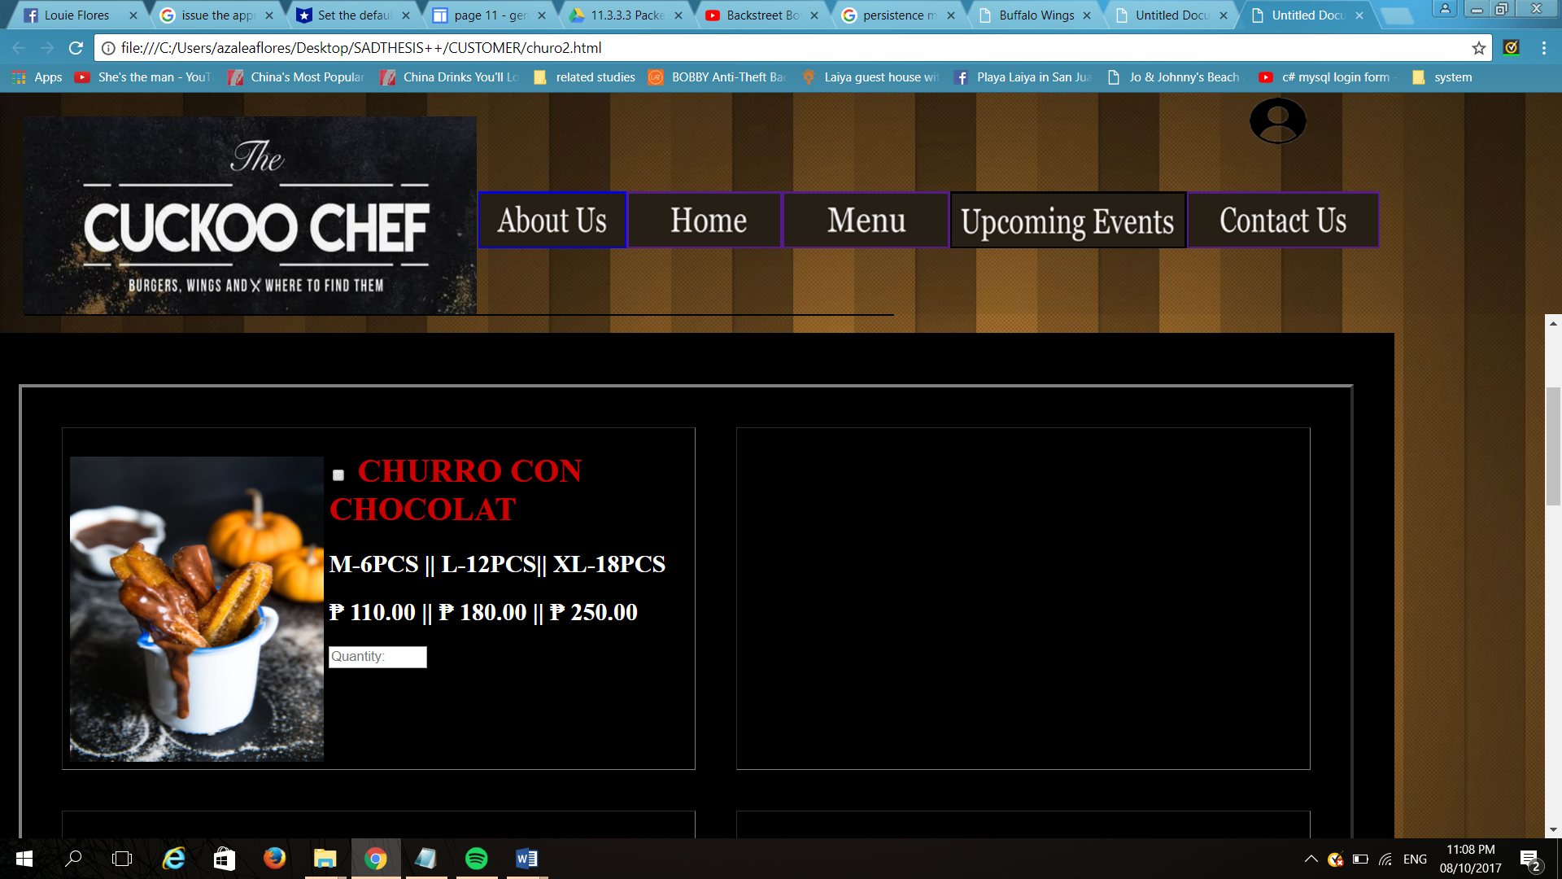

**Churro Selection**

**Figure 3.11**

The figure shows the churro that The Cuckoo Chef Restaurant have, the customer can choose or pick quantity they want, the quantities of the product are 4pcs, 8pcs and 12 pcs. The customer can see the result if they click the churro sign in menu bar.

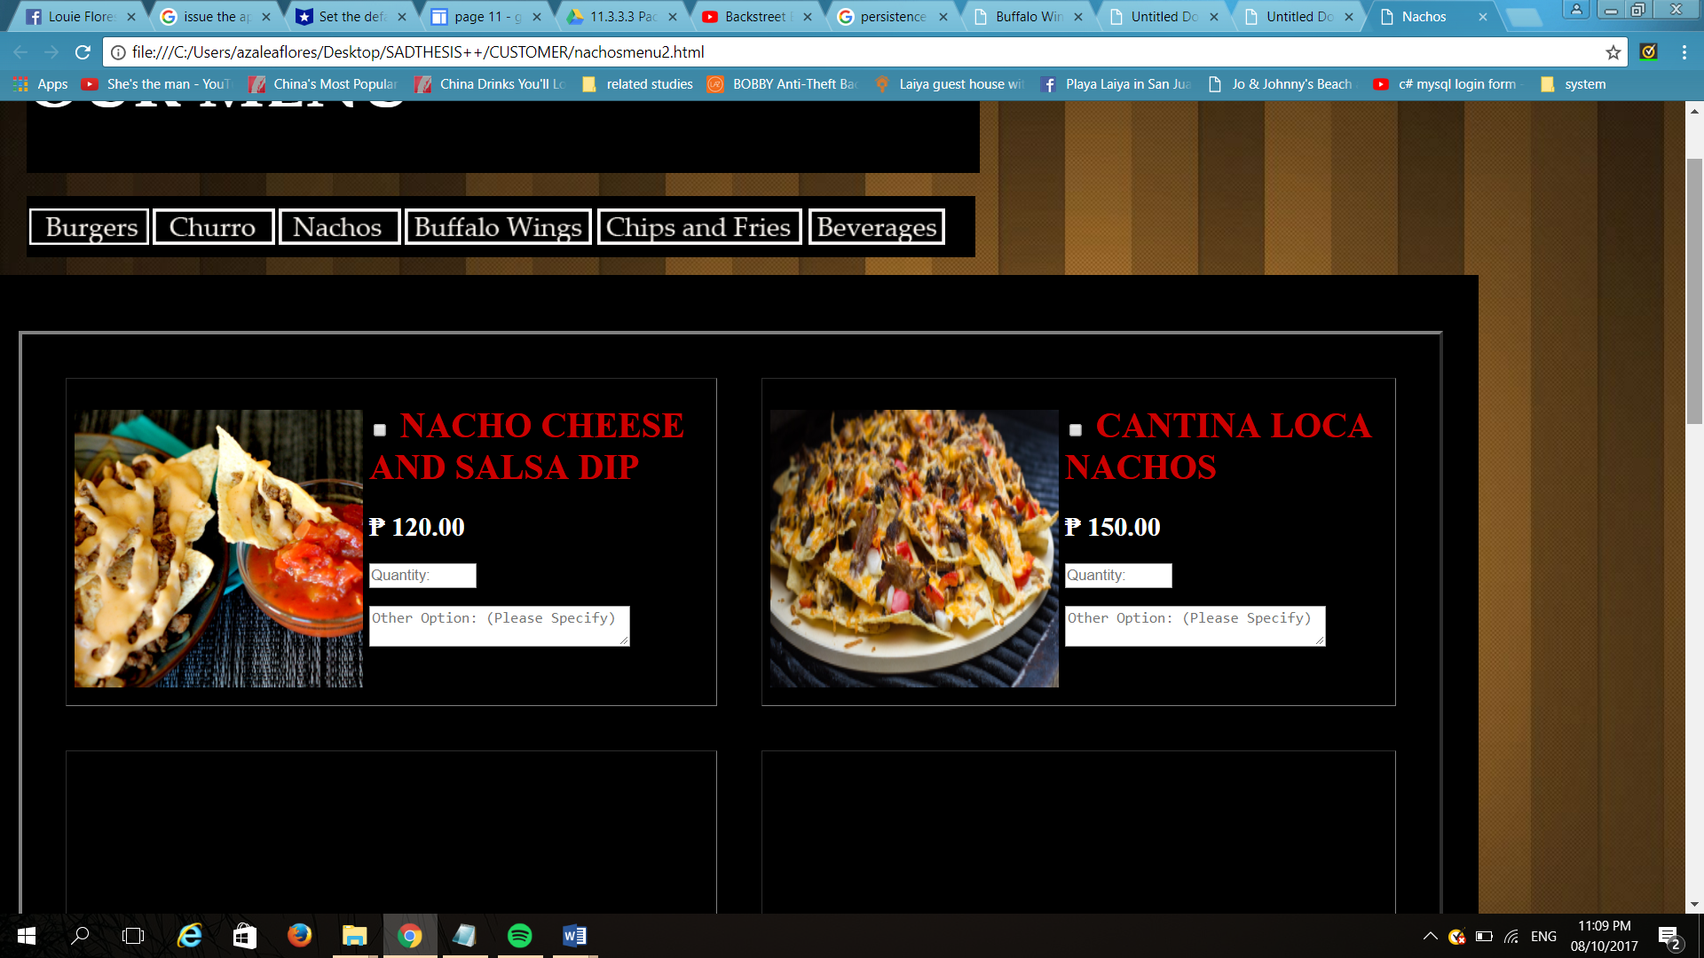

**Nachos Selection**

**Figure 3.12**

This interface shown in figure 3.12 is the nachos that The Cuckoo Chef Restaurant sell, the customer can choose what nachos they prefer. The customer can see this if they click the nachos sign in menu bar.

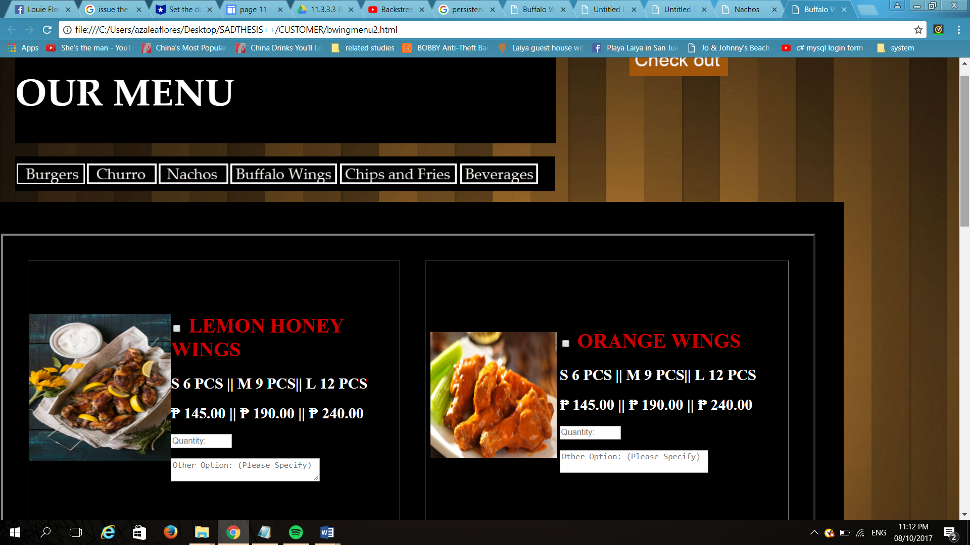

**Buffalo Wings Selection**

**Figure 3.13**

The figure shows the buffalo wings that The Cuckoo Chef Restaurant have , the customer can choose what wings they want, the customer can see this if they click the buffalo wings sign in menu bar.

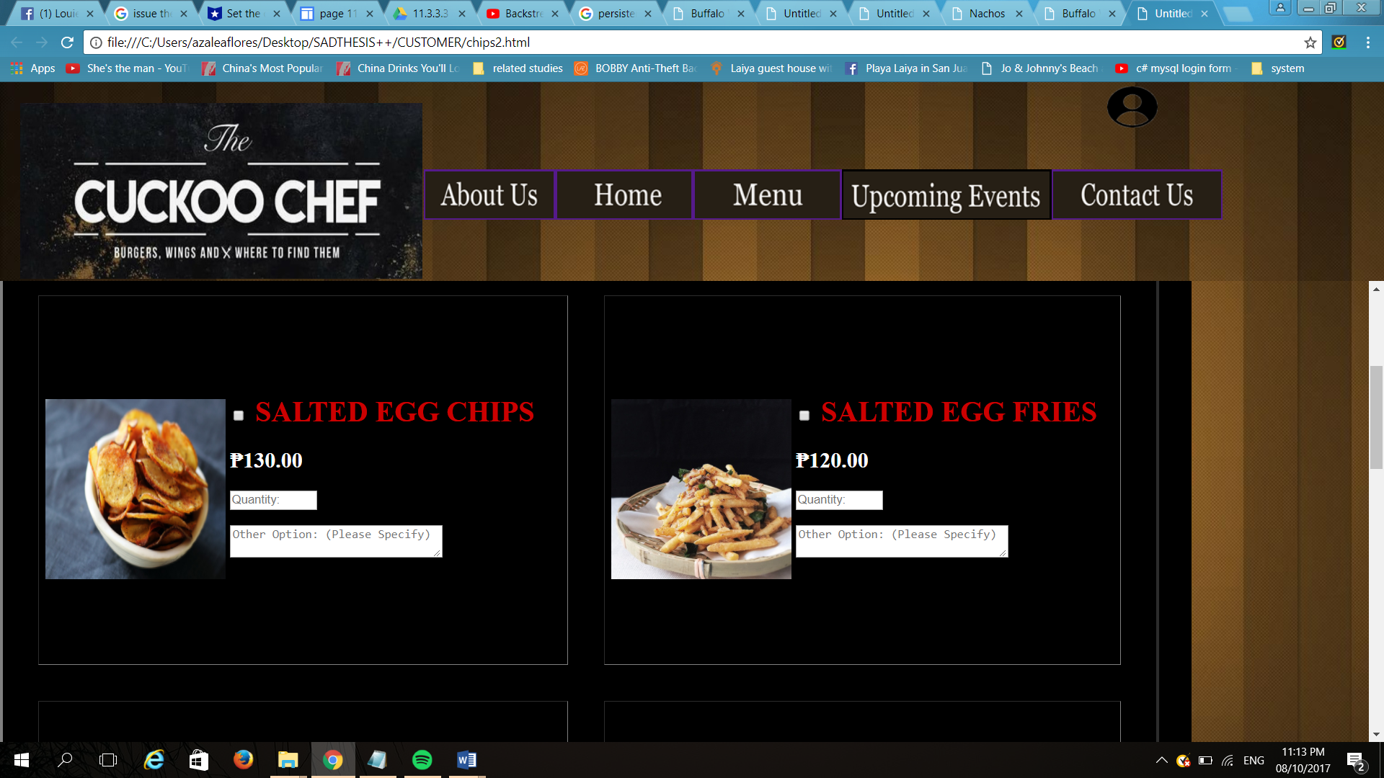

**Chips and Fries Selection**

**Figure 3.14**

The figure shows the chips and fries that The Cuckoo Chef Restaurant offer, the customer can choose want they want or what they prefer if chips or fries. The customer can see this if they select the chips and fries sign in menu bar.

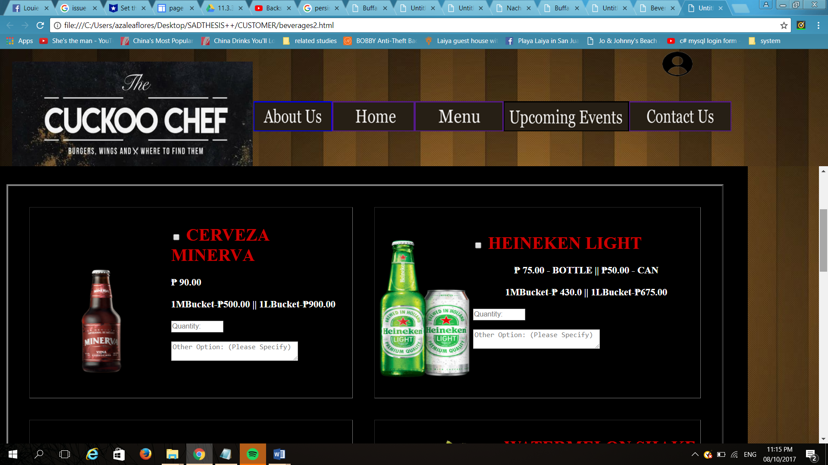

**Beverages Selection**

**Figure 3.15**

This figure 3.15 show the beverages that The Cuckoo Chef Restaurant will sell, the customer can choose want they want or what beverage/s the customer prefers. The cuckoo chef restaurant offers different beverages like juices and alcoholic drinks, and sodas. The customer can see this if they click the beverages sign in menu bar.

**User Interface: Registration Form**



**Account Creation**

**Figure 3.16**

Figure 3.16 shows the interface where the customer can create an account in the webpage ordering system of The Cuckoo Chef Restaurant. Registration contains the first name, the last name, the contact number, the gender, the address, the email, the username, and the password. The customer will input all of the fields in the registration in order to successfully register in the Cuckoo Chef Restaurant. The customer will not be able to register completely if some fields are not filled up. Hence, the customer will be able to have account if the customer filled up all the fields in the registration.

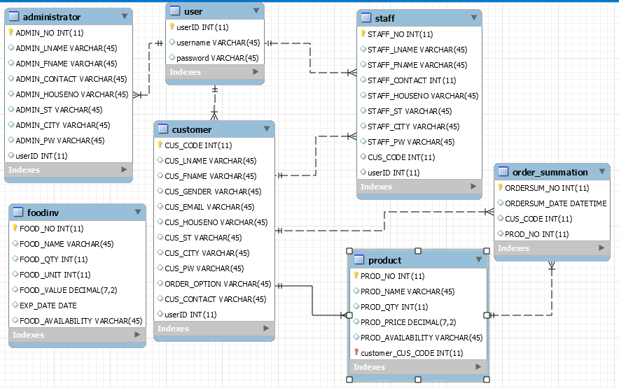

ERD of the Cuckoo Chef Restaurant

Figure 3.17

Figure 3.17 shows the Entity Relationship Diagram of the Cuckoo Chef Restaurant, it shows the entities that are provided for the system and also the attributes that are needed for the entities, and it also shows the relationships between entities in the database. The relationship is the association that describes the interaction between entities.

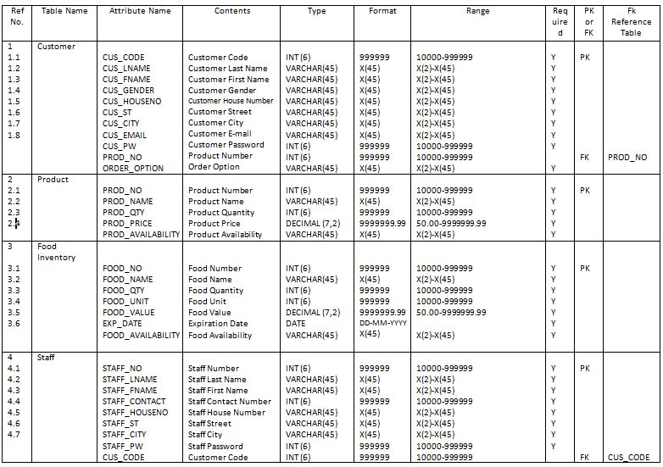

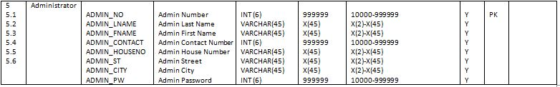

Data Dictionary of Inventory and Ordering System for the Cuckoo Chef Restaurant

Table 3.2

Figure 3.2 shows the information that will describe the contents, format, and structure of the database that will be used for the inventory and ordering system for the Cuckoo Chef Restaurant and the relationship between the elements. The data dictionary will serve as collection of descriptions of the data objects in the data model to benefit people who need to understand the system more.

**Process**

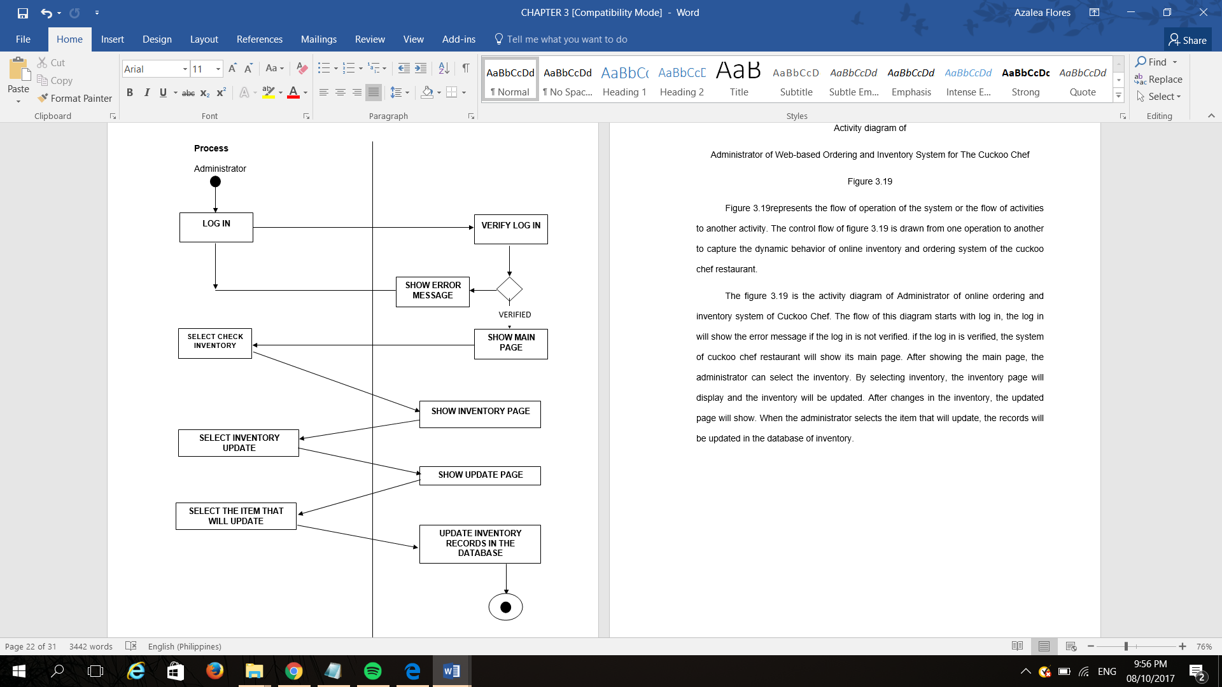

Activity diagram of

Administrator of Web-based Ordering and Inventory System for The Cuckoo Chef

Figure 3.18

Figure 3.18 represents the flow of operation of the system or the flow of activities to another activity. The control flow of figure 3.18 is drawn from one operation to another to capture the dynamic behavior of online inventory and ordering system of the cuckoo chef restaurant.

The figure 3.18 is the activity diagram of Administrator of online ordering and inventory system of Cuckoo Chef. The flow of this diagram starts with log in, the log in will show the error message if the log in is not verified. if the log in is verified, the system of cuckoo chef restaurant will show its main page. After showing the main page, the administrator can select the inventory. By selecting inventory, the inventory page will display and the inventory will be updated. After changes in the inventory, the updated page will show. When the administrator selects the item that will update, the records will be updated in the database of inventory.

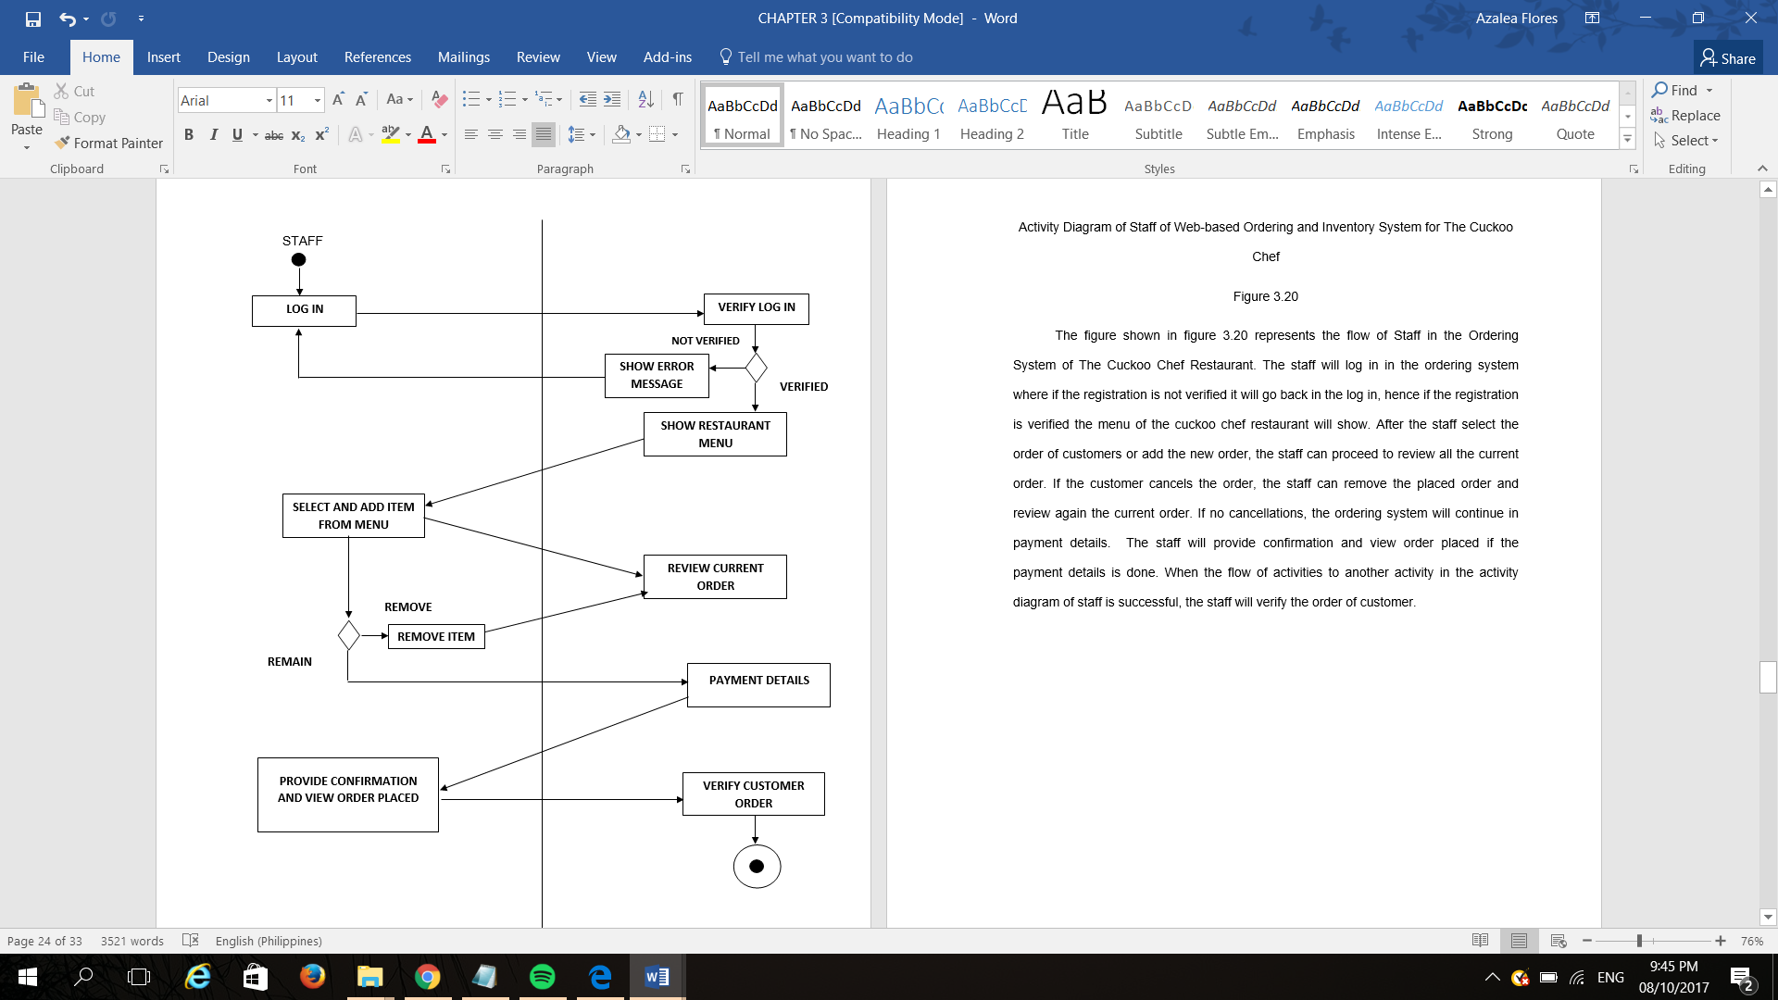

Activity Diagram of Staff of Web-based Ordering and Inventory System for The Cuckoo Chef

Figure 3.19

The figure shown in figure 3.19 represents the flow of Staff in the Ordering System of The Cuckoo Chef Restaurant. The staff will log in in the ordering system where if the registration is not verified it will go back in the log in, hence if the registration is verified the menu of the cuckoo chef restaurant will show. After the staff select the order of customers or add the new order, the staff can proceed to review all the current order. If the customer cancels the order, the staff can remove the placed order and review again the current order. If no cancellations, the ordering system will continue in payment details. The staff will provide confirmation and view order placed if the payment details is done. When the flow of activities to another activity in the activity diagram of staff is successful, the staff will verify the order of customer.

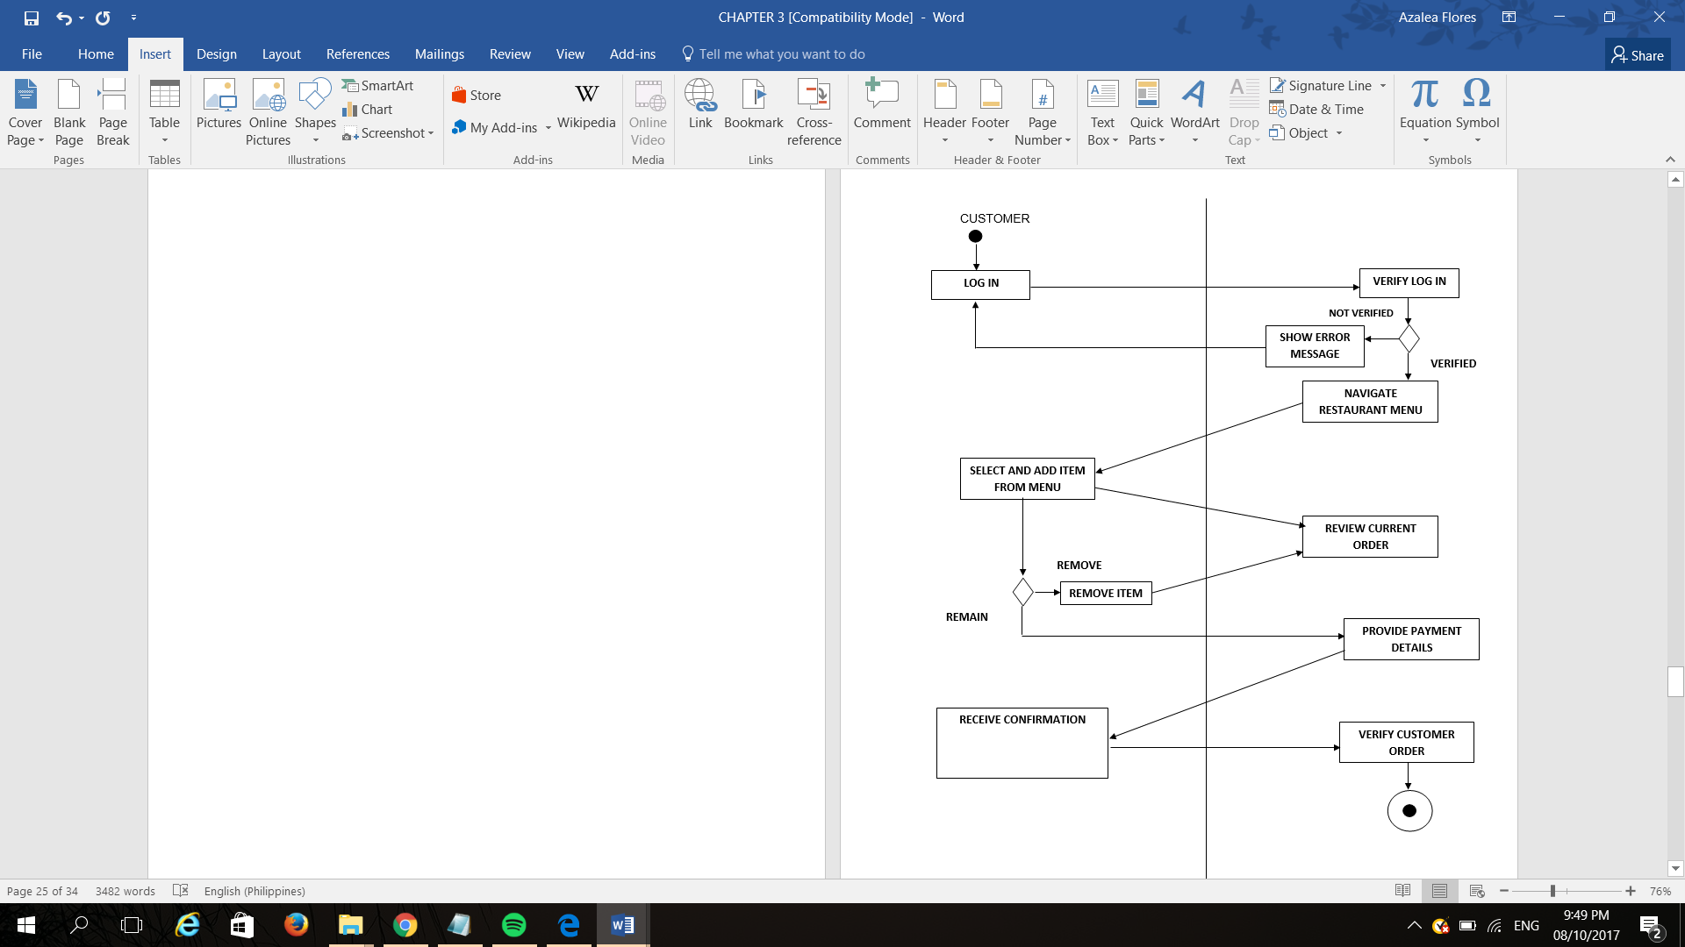

Activity Diagram of Customer of Web-based Ordering and Inventory System for The Cuckoo Chef

Figure 3.20

The figure shown in figure 3.20 is the activity diagram of Customer where a customer is allowed to log in and verify the customer’s information. If not verified, an error message will show and will go back to log in. if the registration of customer is verified, the system will navigate to the restaurant menu and will allow the customer to select and add item from the menu. After the customer select and add item. The customer will review all the current orders. The customer can remove the orders he selected and added and go back to review of current order. If not, the customer will proceed with the payment details and receive confirmation for orders. When confirmations receive, the order of the customer will be verified.

**Output**

The output contains all the interfaces wherein an output is produced from the data entered by the users of the proposed system.

**User Interface: Staff**

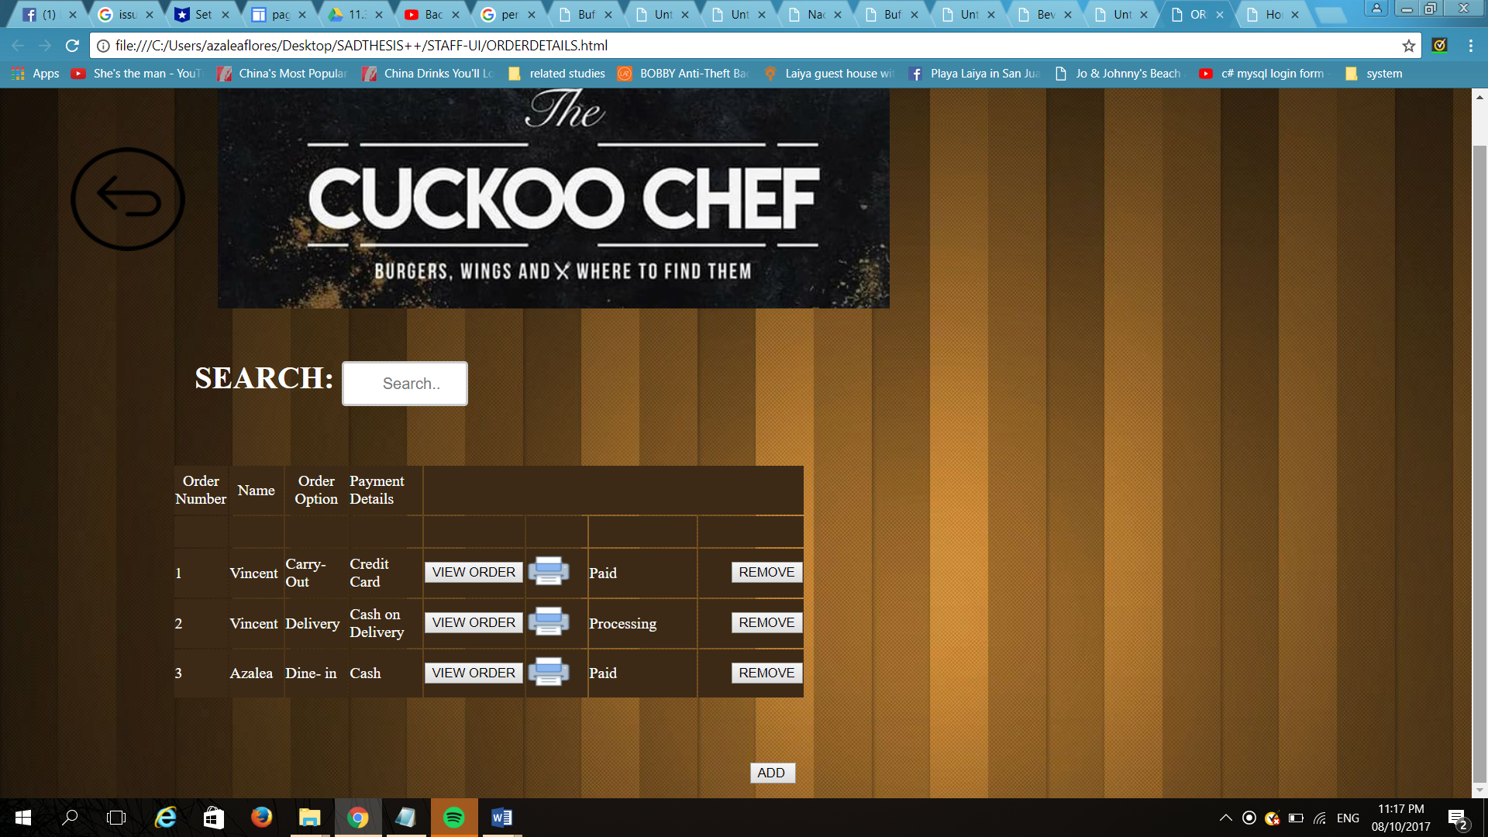

The Customer’s Order Details

Figure 3.21

This figure shows the order details of the customer that the staff can view. It contains the customer’s name and order number, order option whether carry out or delivery, order option, and payment status. It also contains “ADD” button where the staff can click if another order was taken.

**User Interface: Administrator**

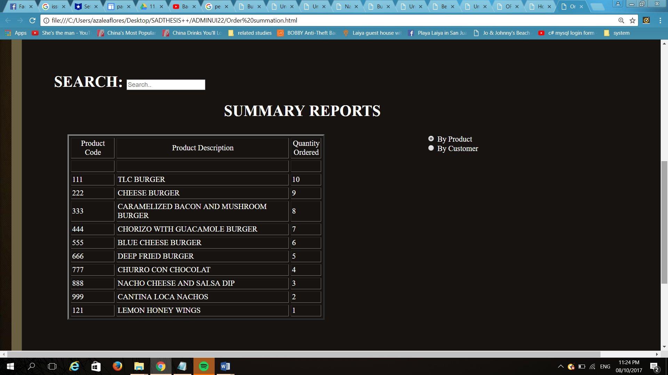

Orders Summary Reports by Product

Figure 3.22

The figure shows the summary of all the orders by product that will be taken from the future day-to-day operations of The Cuckoo Chef Restaurant. The table contains Product code, product description and ordered quantity. The Order Summation will help the administrator to easily know the products that are popular and the least ordered products to be able to know what raw foods must the owner buy and to stock in the food inventory.

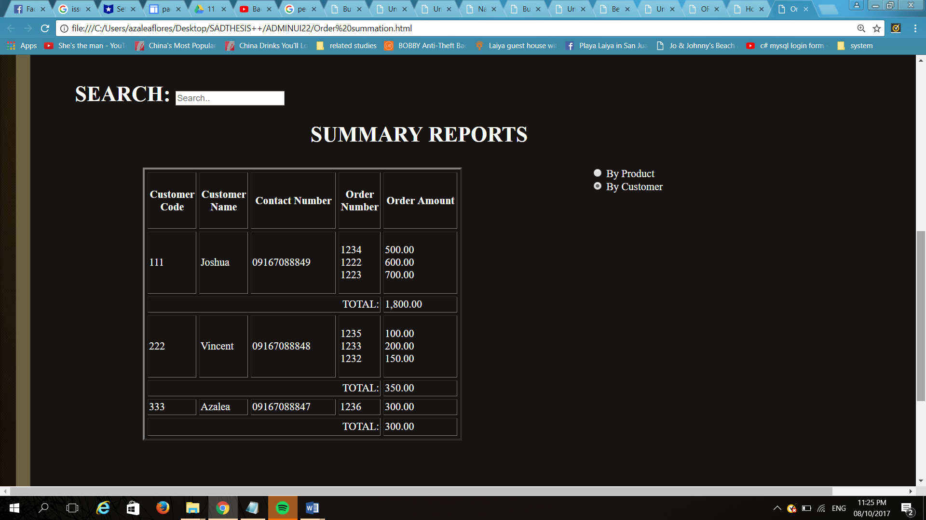

Order Summary Reports Customer

Figure 3.23

Figure 3.23 shows the summary reports of the admin this summary reports by customer where the admin can view the tally of regular customers that buys regularly. The importance of keeping accounts of the customers is to give them promotion.

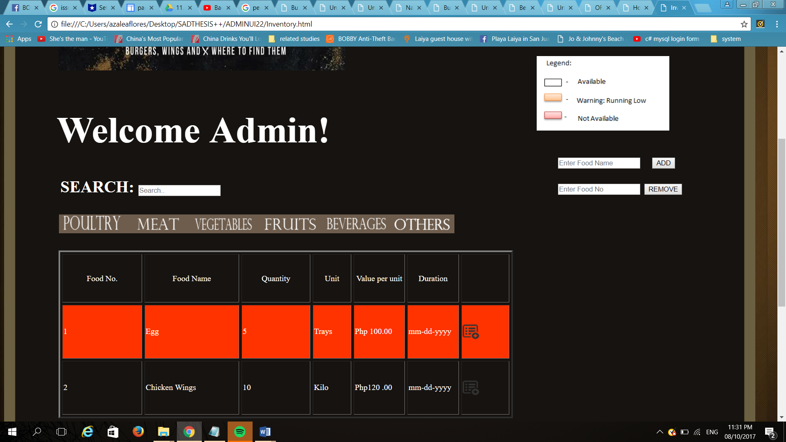

Food Inventory

Figure 3.24

The figure shows the inventory of the raw products of The Cuckoo Chef Restaurant. It contains the number, name, quantity, unit, price value, expiration date and availability of the food product. The inventory is also classified in categories of poultry, meat, vegetables, fruits, beverages and others so the administrator will track the raw foods easily. The food inventory is also designed with alert notifications so that the administrator will be aware if the products are running out or unavailable.

**Software Specification**

The programming language used in developing the prototype of the Ordering and Inventory System for the Cuckoo Chef Restaurant is PHP. PHP is a widely-used open source general-purpose scripting language that is especially suited for web development and can be embedded into HTML. The developers used Adobe Dreamweaver CS5 for creating, coding, editing and managing responsive html and PHP for developing and designing the system prototype. The developers used MySQL Workbench as an IDE for MySQL which provides data modelling, SQL development, and comprehensive administration tools for server configuration, user administration, and backup. The developers also used Adobe Photoshop CC to edit and manipulate digital images and Microsoft Word for the entire documentation.

**Hardware Specification**

The main hardware used by the developers in developing the Ordering and Inventory System for the Cuckoo Chef Restaurant is a laptop which at least has a minimum requirement of a 4GB RAM, has an Intel Core i3 G3220 3.0GHZ to be able to carry out the best resolution for developing the system. The developers used a 15-inch LCD or LED Monitor for wider and high definition screen. All the hardware mentioned are important for developing the system and for it to be able to run properly. The developers also used Ink Jet Printer to test if the system will be able to print out the required reports.

**Program Specification**

The developers used WAMP server to create web applications with Apache2, PHP and a MySQL database. By running a local Apache web server on a Windows machine, the developer can test web pages in a web browser without publishing them live on the Internet. MySQL Workbench should be also being running because for the database of the Cuckoo Chef Restaurant. The developers also used PHP to make the system functional. The developers used Adobe Dreamweaver CS5 as an IDE for PHP to be able to develop and design the system.

**Test Plan**

1. **System Interfaces Test**

|  |  |  |  |  |  |
| --- | --- | --- | --- | --- | --- |
| **Test Case Specification** | **Pre-Requisites** | **Description** | **Expected Result** | **Actual Result** | **Incident Number** |
| AMS TC1 | The “About Us” button is clicked | View the short background of The Cuckoo Chef Restaurant | Short background of The Cuckoo Chef Restaurant will appear |  |  |
| AMS TC2 | The “Home” button is clicked | Enter the created account and login | The User’s profile will appear |  |  |
| AMS TC3 | The “Menu” button is clicked | Choose menu categories of the products available | All the menu categories of the products available will appear |  |  |
| AMS TC4 | The “Upcoming Events” is clicked | View the announcements of the Cuckoo Chef Restaurant | The announcements of the Cuckoo Chef Restaurant will appear |  |  |
| AMS TC5 | The “Contact us” button is clicked | View contact information and location of the Cuckoo Chef Restaurant | The contact information and location of the Cuckoo Chef Restaurant will appear |  |  |
| AMS TC6 | The hyperlinked  “Sign up here” is clicked | Enter the required fields for the registration form | The registration form will appear |  |  |

Table System Interfaces Test

Table 3.3

1. **System Interface: Administrator**

|  |  |  |  |  |  |
| --- | --- | --- | --- | --- | --- |
| **Test Case Specification** | **Pre-Requisites** | **Description** | **Expected Result** | **Actual Result** | **Incident Number** |
| AMS TC1 | Logged in as administrator then clicked Inventory | Access the administrator account | The Food Inventory will appear |  |  |
| AMS TC6 | Logged in as administrator then clicked Order Summation | Access the administrator account | The Order Summation will appear |  |  |

**Table of System Interface: Administrator**

**Table 3.4**

1. **System interface: Staff**

|  |  |  |  |  |  |
| --- | --- | --- | --- | --- | --- |
| **Test Case Specifications** | **Pre-Requisites** | **Description** | **Expected Result** | **Actual Result** | **Incident Number** |
| AMS TC1 | Logged in as staff | Access the staff account | The Order details of the Customer will appear |  |  |

System Interface: Staff

Table 3.5

**CHAPTER 4**

**Results and Findings**

In this chapter, the readers can find the results and findings of the Ordering and Inventory System for the Cuckoo Chef Restaurant. The system is the first system that will be used by the restaurant. It will help the administrator to easily monitor the food inventory, to know the popular products that are mostly ordered by the customers and also to know the less popular products, and the availability of the food products. It will also help the staff to know the customer’s order details from the menu for them to serve it to the customer correctly. The system is secured because every interface can be viewed depending on whose user will log-in. This chapter includes the software, hardware and program specification that is used for developing the system prototype.

**Software Specification**

The programming language used in developing the prototype of the Ordering and Inventory System for the Cuckoo Chef Restaurant is PHP. PHP is a widely-used open source general-purpose scripting language that is especially suited for web development and can be embedded into HTML. The developers used Adobe Dreamweaver CS5 for creating, coding, editing and managing responsive html and PHP for developing and designing the system prototype. The developers used MySQL Workbench as an IDE for MySQL which provides data modelling, SQL development, and comprehensive administration tools for server configuration, user administration, and backup. The developers also used Adobe Photoshop CC to edit and manipulate digital images and Microsoft Word for the entire documentation.

**Hardware Specification**

The main hardware used by the developers in developing the Ordering and Inventory System for the Cuckoo Chef Restaurant is a laptop which at least has a minimum requirement of a 4GB RAM, has an Intel Core i3 G3220 3.0GHZ to be able to carry out the best resolution for developing the system. The developers used a 15 inch LCD or LED Monitor for wider and high definition screen. All the hardware mentioned are important for developing the system and for it to be able to run properly. The developers also used Ink Jet Printer to test if the system will be able to print out the required reports.

**Program Specification**

The developers used WAMP server to create web applications with Apache2, PHP and a MySQL database. By running a local Apache web server on a Windows machine, the developer can test web pages in a web browser without publishing them live on the Internet. MySQL Workbench should be also be running because for the database of the Cuckoo Chef Restaurant. The developers also used PHP to make the system functional. The developers used Adobe Dreamweaver CS5 as an IDE for PHP to be able to develop and design the system prototype.

**SQL QUERIES**

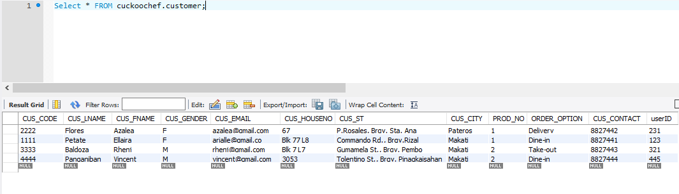

Customer Table

Figure 4.1

The figure shows the Customer’s information record inserted in the Registration Form and their orders. It contains the Customer’s code for unique identification, name, gender, email, address, contact number, user ID and the product they order and also the order option. The customer’s name and the product they ordered will be inserted in the Order Details Report where the Staff can view.

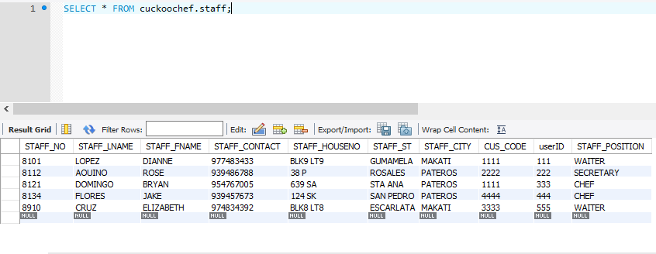

STAFF TABLE

Figure 4.2

This figure shows the Staff table where all the records of the staff’s information are inserted. It contains the Staff number for unique identification, name, contact number, address, user ID and their position. It also includes the Customer’s code for them to know the customer’s information and what they have ordered.

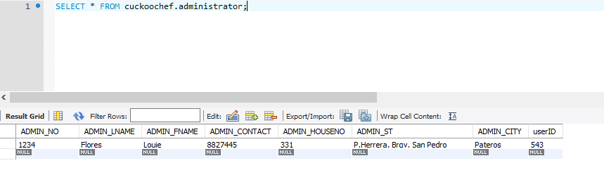

Administrator User

Figure 4.3

This figure shows the administrator’s information. It contains the admin’s unique identification, name, contact number, address and user ID. The administrator will be the owner of the Cuckoo Chef Restaurant.

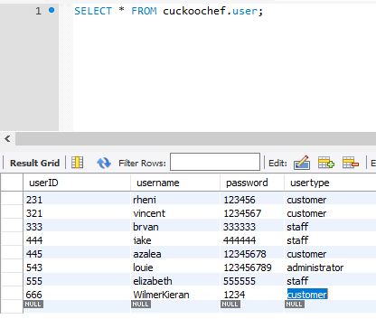

User’s Account Table

Figure 4.4

The figure shows the user’s account table. It contains the userID for unique identification, username, password, and user type. This table will show the entire user that will register in the web page of the Cuckoo Chef Restaurant.

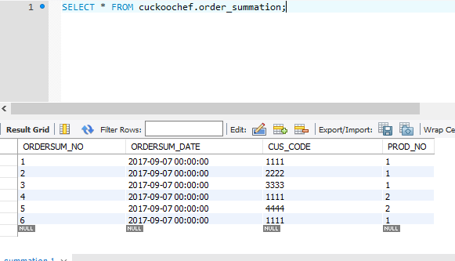

Order Summation Table

Figure 4.5

This figure shows the order summation table. This table shows all the summaries of the orders that will be made by the Cuckoo Chef restaurant to know the most popular products. It contains the “ORDERSUM_NO” for unique identification, date, “CUS_CODE” which is the foreign key from the customer’s table and “PROD_NO” which is also the foreign key from the product’s table.

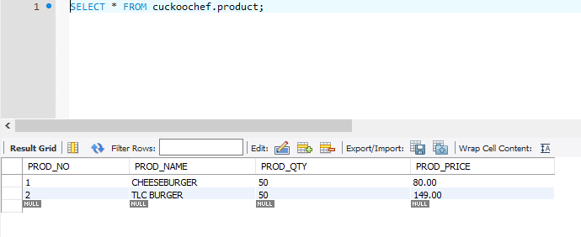

Product Table

Figure 4.6

This figure shows the product details. It contains the product number for unique identification, product name, quantity of the product and its price. This table will contain all the products of the Cuckoo Chef Restaurant.

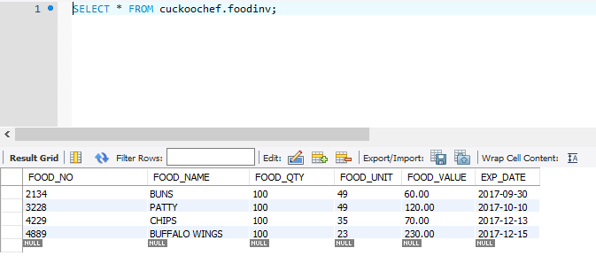

Food Inventory Table

Figure 4.7

This figure shows the food inventory table. It contains the food number for unique identification, food’s name, quantity, unit for the remaining stocks and its price and expiration date. This table shows all the raw products and ingredients that will be used for the products in the Menu of The Cuckoo Chef restaurant except for the condiments.

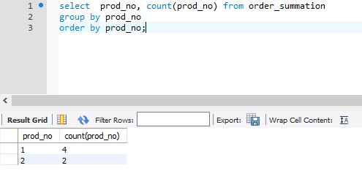

Orders Tally

Figure 4.8

This figure shows the total number of the products that will be ordered. It contains the sql queries from the Order Summation Table to compute the total number of the product ordered by the customer.

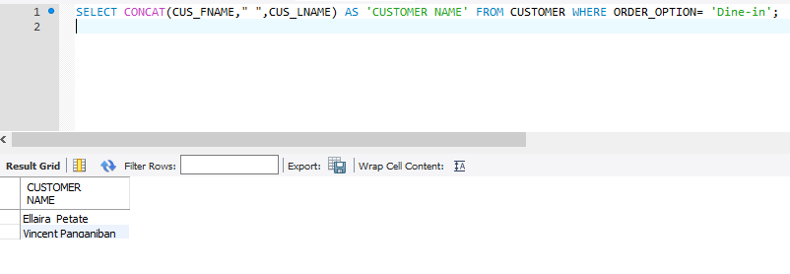

Searching Customer’s Order Option

Figure 4.9

This figure shows the sql query for searching the customer who selected “Dine –in” as their order option. It contains the query select, concat, alias, and where clauses.

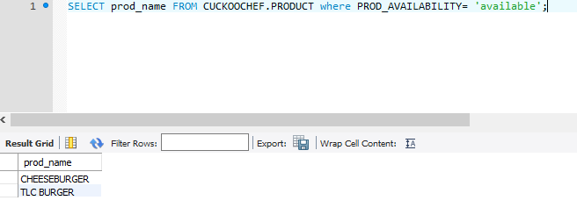

Searching Product’s Availability

Figure 4.10

This figure shows the sql query for searching the product’s availability. It shows the sql query select and where clauses to find all the products available.

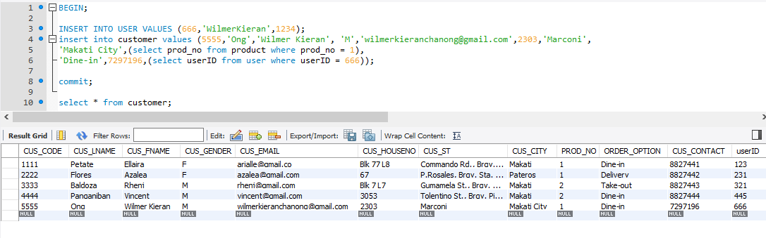

Inserting Customer Information

Figure 4.11

This figure shows the sql query for inserting customer’s information. It contains the Customer’s table. All the inputted data in the Registration Form in the web page of the Cuckoo Chef restaurant will be inserted in this table.

**Test Results**

|  |  |  |  |  |  |
| --- | --- | --- | --- | --- | --- |
| **Test Case Specification** | **Pre-Requisites** | **Description** | **Expected Result** | **Actual Result** | **Incident Number** |
| AMS TC1 | The “About Us” button is clicked | View the short background of The Cuckoo Chef Restaurant | Short background of The Cuckoo Chef Restaurant will appear | Short background of The Cuckoo Chef Restaurant appeared |  |
| AMS TC2 | The “Home” button is clicked | Enter the created account and login | The User’s profile will appear | The User’s profile appeared |  |
| AMS TC3 | The “Menu” button is clicked | Choose menu categories of the products available | All the menu categories of the products available will appear | All the menu categories of the products available appeared |  |
| AMS TC4 | The “Upcoming Events” is clicked | View the announcements of the Cuckoo Chef Restaurant | The announcements of the Cuckoo Chef Restaurant will appear | The announcements of the Cuckoo Chef Restaurant appeared |  |
| AMS TC5 | The “Contact us” button is clicked | View contact information and location of the Cuckoo Chef Restaurant | The contact information and location of the Cuckoo Chef Restaurant will appear | The contact information and location of the Cuckoo Chef Restaurant appeared |  |
| AMS TC6 | The hyperlinked  “Sign up here” is clicked | Enter the required fields for the registration form | The registration form will appear | The registration form appeared |  |

System Interfaces Test

Table 4.1

|  |  |  |  |  |  |
| --- | --- | --- | --- | --- | --- |
| **Test Case Specification** | **Pre-Requisites** | **Description** | **Expected Result** | **Actual Result** | **Incident Number** |
| AMS TC1 | Logged in as administrator then clicked Inventory | Access the administrator account | The Food Inventory will appear | The Food Inventory appeared |  |
| AMS TC6 | Logged in as administrator then clicked Order Summation | Access the administrator account | The Order Summation will appear | The Order Summation appeared |  |

System Interface: Administrator

Table 4.2

|  |  |  |  |  |  |
| --- | --- | --- | --- | --- | --- |
| **Test Case Specifications** | **Pre-Requisites** | **Description** | **Expected Result** | **Actual Result** | **Incident Number** |
| AMS TC1 | Logged in as staff | Access the staff account | The Order details of the Customer will appear | The Order details of the Customer appeared |  |

System Interface: Staff

Table 4.3

**Chapter 5**

**CONCLUSIONS AND RECOMMENDATION**

This chapter will contain the conclusion and recommendation of the entire project. The conclusion of this project will show the overview of all the inputs, outputs, activities and result when the system is already developed. The recommendation will include all the suggestion in the future if the system will be successful.

**Conclusion**

The system prototype development focused mainly on how to help Ordering and Inventory System for The Cuckoo Chef Restaurant with regards to their inventory and ordering system. The project aimed to help The Cuckoo Chef Restaurant to be more recognizable when the business is established. So the system analyst will have a designed and a developed system prototype that will cater the business’ requirments. The system analysts will create a system for the business to be more competative with other businesses.

The proposed system includes three actors: the owner, the customers and the staffs. The customers are the people who are capable to request information and suggest recommendation to the system. The customers can access and register through the website created. It contains a homepage where the customer can log-in and register to The Cuckoo Chef Restaurant page; and a registration form for the customer. The Staff is the one who can list all the food, provide food info, get customer info and to deliver food to customers. The owner is the one who can produce food facilitate to the business. The Cuckoo chef Restaurant page contains the ‘about us’ where the basic information of the page will be seen; The page also have a menu to check what available products that the business have; the business also have upcoming events to know what events for each day and to know also what promo that The Cuckoo Chef Restaurant have. The page will also have a contact information for the customer to contact the staff or the owner to order and deliver a product. The system analyst will use several softwares, hardwares and programming language for the softwares. The system analysts used Adobe Dreamweaver CS5, Adobe Photoshop CS5, and PHP for the software. The most important component is the desktop or laptop with the specifications of 4GB and a quad core @2.4GHZ(I3) to use. For the programming language, PHP is used as scripting language to cater what the websites needs that the HTML is not capable of doing, HTML and Adobe dreamweaver CS5 is used to design and development the website. Lastly, the My SQL was used to DDL and DML to store, handle and manipulate data being entered from the system and to produce several outputs that the business needs.

The developed system prototype will have a tangible and intangible benefits to The Cuckoo Chef Restaurant. Tangible benefits such as the increase of the customer when the business is established. Intangible benefits includes updating of the websites of The Cuckoo Chef Restaurant and to know some offer of promo and some events of the business using new technology. With new technology, the system can lessen the time and help the customer service.

In conclusion, the system only includes all the necessary activities needed to be done in ordering and inventory process. The system is made to help and grow the business fast.

**Recommendation**

This System of Inventory and Ordering for the Cuckoo Chef restaurant is composed of Inventory of the products so that the administrator can easily update, record and manage the products on hand. The use of ordering system will be also a big factor for the company because the ordering system will make the employee’s work easier and more proficient. the customer will have more time to use the system easily. However, this system needs to be improved to become more user-friendly. Based on the projects conclusion and results collected, the system analysts have come up with the following recommendations: First, let the system indicate the bestsellers of the restaurant to know immediately the products to be sell more. And second, is to expand the location of delivering so the other customer can order even though they are far. Third is in user interface the text field for staff page instead of dropdown, combine of size and price, enlarge location image, make the signage big for every website, make every color of the design visible, system supplied date, and notifications of discount/promotions for always buyer customers.